IEEE P802.15
Wireless Personal Area Networks

Project | IEEE P802.15 Working Group for Wireless Personal Area Networks (WPANs)
Title | Multi-band OFDM Physical Layer Proposal for IEEE 802.15 Task Group 3a
Date Submitted | March, 2004
Source | [Anuj Batra et al.]  [Texas Instruments et al.]  [12500 TI Blvd, Dallas, TX 75243] | Voice: [214-480-4220]  Fax: [972-761-6966]  E-mail: [batra@ti.com]
Re: | [If this is a proposed revision, cite the original document.]  [If this is a response to a Call for Contributions, cite the name and date of the Call for Contributions to which this document responds, as well as the relevant item number in the Call for Contributions.]  [Note: Contributions that are not responsive to this section of the template, and contributions which do not address the topic under which they are submitted, may be refused or consigned to the “General Contributions” area.]
Abstract | A high rate WPAN with data rates from 55 Mbps to 480 Mbps is proposed.
Purpose | Discussion
Notice | This document has been prepared to assist the IEEE P802.15. It is offered as a basis for discussion and is not binding on the contributing individual(s) or organization(s). The material in this document is subject to change in form and content after further study. The contributor(s) reserve(s) the right to add, amend or withdraw material contained herein.
Release | The contributor acknowledges and accepts that this contribution becomes the property of IEEE and may be made publicly available by P802.15.

Physical Layer Submission to 802.15 Task Group 3a:
Multi-band Orthogonal Frequency Division Multiplexing

Authors
Texas Instruments:
A. Batra, J. Balakrishnan, A. Dabak, R. Gharpurey, J. Lin, P. Fontaine, J.-M. Ho, S. Lee, M. Frechette, S. March, H. Yamaguchi
femto Devices:
J. Cheah
FOCUS Enhancements:
K. Boehlke
General Atomics:
J. Ellis, N. Askar, S. Lin, D. Furuno, D. Peters, G. Rogerson, M. Walker
Institute for Infocomm Research:
F. Chin, Madhukumar, X. Peng, Sivanand
Intel:
J. Foerster, V. Somayazulu, S. Roy, E. Green, K. Tinsley, C. Brabenac, D. Leeper, M. Ho

Mitsubishi Electric:
A. F. Molisch, Y.-P. Nakache, P. Orlik, J. Zhang
Panasonic:
S. Mo
Philips:
C. Razzell, D. Birru, B. Redman-White, S. Kerry
Samsung Advanced Institute of Technology:
D. H. Kwon, Y. S. Kim

Samsung Electronics:
M. Park
SONY:
E. Fujita, K. Watanabe, K. Tanaka, M. Suzuki, S. Saito, J. Iwasaki, B. Huang

Staccato Communications:
R. Aiello, T. Larsson, D. Meacham, L. Mucke, N. Kumar
STMicroelectronics:
D. Hélal, P. Rouzet, R. Cattenoz, C. Cattaneo, L. Rouault, N. Rinaldi, L. Blazevic,
C. Devaucelle, L. Smaïni, S. Chaillou
Time Domain:
J. Kelly, M. Pendergrass
Wisair:
G. Shor, Y. Knobel, D. Yaish, S. Goldenberg, A. Krause, E. Wineberger, R. Zack,
B. Blumer, Z. Rubin, D. Meshulam, A. Freund

Table of Contents

1 UWB Physical Layer 6
1.1 Introduction 6
1.1.1 Overview of the proposed UWB system description 6
1.1.1.1 Mathematical description of the signal 6
1.1.1.2 Discrete-time implementation considerations 7
1.1.2 Scope 8
1.1.3 UWB PHY function 8
1.1.3.1 PLCP sublayer 9
1.1.3.2 PMD sublayer 9
1.1.3.3 PHY management entity (PLME) 9
1.2 UWB PHY specific service parameter list 10
1.2.1 Introduction 10
1.2.2 TXVECTOR parameters 10
1.2.2.1 TXVECTOR LENGTH 10
1.2.2.2 TXVECTOR DATARATE 11
1.2.2.3 TXVECTOR SCRAMBLER_INIT 11
1.2.2.4 TXVECTOR TXPWR_LEVEL 11
1.2.3 RXVECTOR parameters 11
1.2.3.1 RXVECTOR LENGTH 11
1.2.3.2 RXVECTOR RSSI 11
1.2.3.3 RXVECTOR DATARATE 12
1.3 UWB PLCP sublayer 13
1.3.1 Introduction 13
1.3.2 PLCP frame format 13
1.3.2.1 RATE-dependent parameters 13
1.3.2.2 Timing-related parameters 14
1.3.3 PLCP preamble 14
1.3.4 PHY header 23
1.3.4.1 Date rate (RATE) 23
1.3.4.2 PLCP length field (LENGTH) 24
1.3.4.3 PLCP scrambler field (SCRAMBLER) 24
1.3.5 Header modulation 24
1.3.6 Data scrambler 24
1.3.7 Tail bits 25
1.3.8 Convolutional Encoder 25
1.3.9 Pad bits 29
1.3.10 Bit interleaving 29
1.3.11 Subcarrier constellation mapping 30
1.3.13 OFDM modulation 31
1.3.13.1 Pilot subcarriers 33
1.3.13.2 Guard subcarriers 33
1.3.14 Time-domain Spreading 34
1.4 General requirements 35
1.4.1 Operating band frequencies 35
1.4.1.1 Operating frequency range 35
1.4.1.2 Band numbering 35
1.4.2 Channelization 36
1.4.3 PHY layer timing 36
1.4.3.1 Interframe spacing 36
1.4.3.2 Receive-to-transmit turnaround time 37
1.4.3.3 Transmit-to-receive turnaround time 37
1.4.3.4 Time between successive transmissions 37
1.4.3.5 Channel switch time 37
1.4.4 Header check sequence 37
1.5 Transmitter specifications 39
1.5.1 Transmit PSD mask 39
1.5.2 Transmit center frequency tolerance 39
1.5.3 Symbol clock frequency tolerance 39
1.5.4 Clock synchronization 39
1.6 Receiver specification 40
1.6.1 Receiver sensitivity 40
1.6.2 Receiver CCA performance 40
2 Self evaluation matrix 41
2.1 General solution criteria 41
2.2 PHY protocol criteria 42
2.3 MAC protocol enhancement criteria 43
3 Detailed responses to selection criteria and self-evaluation matrix 44
3.1 Unit manufacturing cost 44
3.2 Signal robustness 44
3.2.2 Interference and susceptibility 44
3.2.2.1 Microwave oven 45
3.2.2.2 Bluetooth and IEEE 802.15.1 interferer 45
3.2.2.3 IEEE 802.11b and IEEE 802.15.3 interferer 45
3.2.2.4 IEEE 802.11a interferer 46
3.2.2.5 IEEE 802.15.4 interferer 46
3.2.2.6 Generic in-band modulated interferer 46
3.2.2.7 Generic in-band tone interferer 47
3.2.2.8 Out-of-band interference from intentional and unintentional radiators 48
3.2.3 Coexistence 48
3.2.3.1 IEEE 802.11a interferer 49
3.2.3.2 IEEE 802.11b interferer 49
3.3 Technical feasibility 49
3.3.1 Manufacturability 49
3.3.2 Time to market 49
3.3.3 Regulatory impact 49
3.4 Scalability 50
3.5 Location awareness 50
4 Alternate PHY required MAC enhancements and modifications 51
4.1 Introduction 51
4.2 Frame format enhancement for time-frequency coding 51
4.2.1 Time-frequency coding information element 51
4.2.2 Beacon frame 52
4.3 Management enhancements for time-frequency coding 52
4.3.1 TFC PHY PIB 52
5 PHY layer criteria 53
5.1 Size and form factor 53
5.2 PHY-SAY payload bit rate and data throughput 53
5.2.1 Payload bit rate 53
5.2.2 Packet overhead for a Mode 1 device 53
5.2.3 PHY-SAP throughput for a Mode 1 device 54
5.3 Simultaneously operating piconets 54
5.4 Signal acquisition 57
5.5 System 59
5.6 Link budget 64
5.7 Sensitivity 65
5.8 Power management modes 65
5.9 Power consumption 65
5.10 Antenna practicality 66

UWB Physical Layer

Introduction

This clause specifies the PHY entity for a UWB system that utilizes the unlicensed 3.1 – 10.6 GHz UWB band, as regulated in the United States by the Code of Federal Regulations, Title 47, Section 15. The UWB system provides a wireless PAN with data payload communication capabilities of 53.3, 55, 80, 106.67, 110, 160, 200, 320, and 480 Mb/s. The support of transmitting and receiving at data rates of 53.3, 106.67, 110, and 200 Mb/s is mandatory. The proposed UWB system employs orthogonal frequency division multiplexing (OFDM). The system uses a total of 122 sub-carriers that are modulated using quadrature phase shift keying (QPSK). Forward error correction coding (convolutional coding) is used with a coding rate of 1/3, 11/32, ½, 5/8, and ¾. The proposed UWB system also utilizes a time-frequency code (TFC) to interleave coded data over 3 frequency bands (called a band group). Four such band groups with 3 bands each and one band group with 2 bands are defined. There are also 4 3-band TFCs and 2 2-band TFCs, which, when combined with the appropriate band groups provide the capability to define eighteen separate logical channels or independent piconets. Devices operating in band group #1 (the three lowest frequency bands) are denoted Mode 1 devices, it shall be mandatory for all devices to support Mode 1 operation, with support for the other band groups being optional and added over time.

Overview of the proposed UWB system description

Mathematical description of the signal

The transmitted signals can be described using a complex baseband signal notation. The actual RF transmitted signal is related to the complex baseband signal as follows:

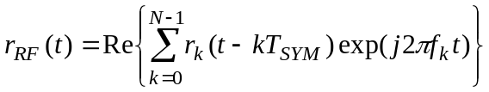,

where Re(⋅) represents the real part of a complex variable, r_{k}(t) is the complex baseband signal of the k^{th} OFDM symbol and is nonzero over the interval from 0 to T_{SYM}, N is the number of OFDM symbols, T_{SYM} is the symbol interval, and f_{k} is the center frequency for the k^{th} band. The exact structure of the k^{th} OFDM symbol depends on its location within the packet:

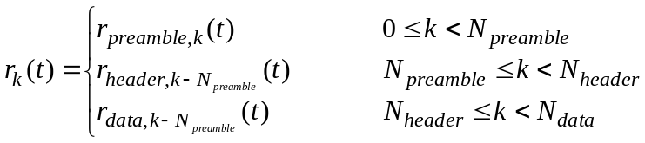.

The structure of each component of r_{k}(t) as well as the offsets N_{preamble}, N_{header}, and N_{data} will be described in more detail in the following sections.

All of the OFDM symbols r_{k}(t) can be constructed using an inverse Fourier transform with a certain set of coefficient C_{n}, where the coefficients are defined as either data, pilots, or training symbols:

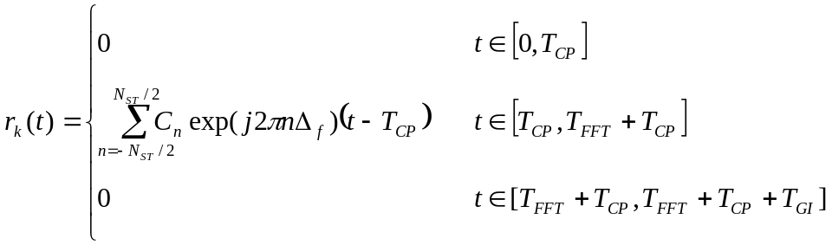.

The parameters Δ_{f} and N_{ST} are defined as the subcarrier frequency spacing and the number of total subcarriers used, respectively. The resulting waveform has a duration of T_{FFT} = 1/Δ_{f}. Shifting the time by T_{CP} creates the “circular prefix” which is used in OFDM to mitigate the effects of multipath. The parameter T_{GI} is the guard interval duration.

Discrete-time implementation considerations
The following description of the discrete time implementation is informational. The common way to implement the inverse Fourier transform is by an inverse Fast Fourier Transform (IFFT) algorithm. If, for example, a 128-point IFFT is used, the coefficients 1 to 61 are mapped to the same numbered IFFT inputs, while the coefficients –61 to –1 are copied into IFFT inputs 67 to 127. The rest of the inputs, 62 to 66 and the 0 (DC) input, are set to zero. This mapping is illustrated in Figure 1. After performing the IFFT, a zero-padded prefix of length 32 is pre-appended to the IFFT output and a guard interval is added at the end of the IFFT output to generate an output with the desired length of 165 samples.

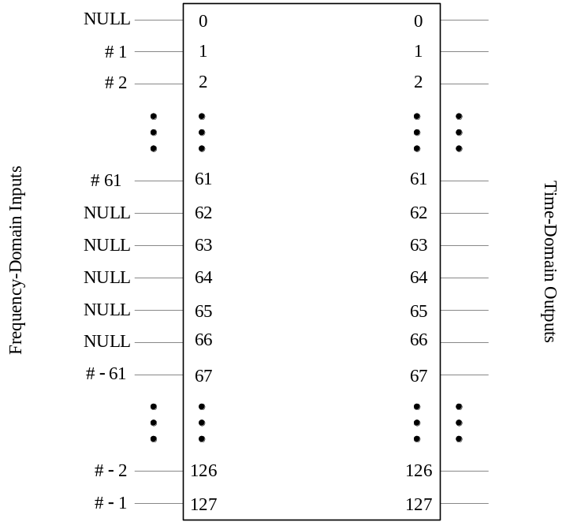

Figure 1 – Input and outputs of IFFT

Scope

This subclause describes the PHY services provided to the IEEE 802.15.3 wireless PAN MAC. The OFDM PHY layer consists of two protocol functions, as follows:

- A PHY convergence function, which adapts the capabilities of the physical medium dependent (PMD) system to the PHY service. This function is supported by the physical layer convergence procedure (PLCP), which defined a method of mapping the IEEE 802.15 PHY sublayer service data units (PSDU) into a framing format suitable for sending and receiving user data and management information between two or more stations using the associated PMD system.

- A PMD system whose function defines the characteristics and method of transmitting and receiving data through a wireless medium between two or more stations, each using the OFDM system.

UWB PHY function

The UWB PHY contains three functional entities: the PMD function, the PHY convergence function, and the layer management function. The UWB PHY service is provided to the MAC through the PHY service primitives.

PLCP sublayer

In order to allow the IEEE 802.15.3 MAC to operate with minimum dependence on the PMD sublayer, a PHY convergence sublayer is defined. This function simplifies the PHY service interface to the IEEE 802.15.3 MAC services.

PMD sublayer

The PMD sublayer provides a means to send and receive data between two or more stations.

PHY management entity (PLME)

The PLME performs management of the local PHY functions in conjunction with the MAC management entity.

UWB PHY specific service parameter list

Introduction

Some PHY implementations require medium management state machines running in the MAC sublayer in order to meet certain PMD requirements. This PHY-dependent MAC state machines reside in a sublayer defined as the MAC sublayer management entity (MLME). In certain PMD implementations, the MLME may need to interact with the PLME as part of the normal PHY SAP primitives. These interactions are defined by the PLME parameter list currently defined in the PHY services primitives as TXVECTOR and RXVECTOR. The list of these parameters, and the values they may represent, are defined in the PHY specification for each PMD. This subclause addresses the TXVECTOR and RXVECTOR for the OFDM PHY.

TXVECTOR parameters

The parameters in Table 1 are defined as part of the TXVECTOR parameter list in the PHY-TXSTART.request service primitive.

Table 1 – TXVECTOR parameters
Parameter | Associate Primitive | Value
LENGTH | PHY-TXSTART.request  (TXVECTOR) | 1–4095
DATARATE | PHY-TXSTART.request  (TXVECTOR) | 55, 80, 110, 160, 200, 320, and 480  (Support for 55, 110, and 200 data rates is mandatory.)
SCRAMBLER_INIT | PHY-TXSTART.request  (TXVECTOR) | Scrambler initialization: 2 null bits
TXPWR_LEVEL | PHY-TXSTART.request  (TXVECTOR) | 1–8

TXVECTOR LENGTH

The allowed values for the LENGTH parameter are in the range 1–4095. This parameter is used to indicate the number of octets in the frame payload (which does not include the FCS), which the MAC is currently requesting the PHY to transmit. This value is used by the PHY to determine the number of octets transfers that will occur between the MAC and the PHY after receiving a request to start the transmission.

TXVECTOR DATARATE

The DATARATE parameter describes the bit rate at which the PLCP shall transmit the PSDU. Its value can be any of the rates defined in Table 1. Data rates of 55, 110, and 200 Mb/s shall be supported; other rates may also be supported.

TXVECTOR SCRAMBLER_INIT

The SCRAMBLER_INIT parameter consists of 2 null bits used for the scrambler initialization.

TXVECTOR TXPWR_LEVEL

The allowed values for the TXPWR_LEVEL parameter are in the range from 1–8. This parameter is used to indicate which of the available TxPowerLevel attributes defined in the MIB shall be used for the current transmission.

RXVECTOR parameters

The parameters in Table 2 are defined as part of the RXVECTOR parameter list in the PHY-RXSTART.indicate service primitive.

Table 2 – RXVECTOR parameters
Parameter | Associate Primitive | Value
LENGTH | PHY-RXSTART.indicate  (RXVECTOR) | 1–4095
RSSI | PHY-RXSTART.indicate  (RXVECTOR) | 0–RSSI maximum
DATARATE | PHY-RXSTART.indicate  (RXVECTOR) | 55, 80, 110, 160, 200, 320, and 480

RXVECTOR LENGTH

The allowed values for the LENGTH parameter are in the range 1–4095. This parameter is used to indicate the value contained in the LENGTH field that the PLCP has received in the PLCP header. The MAC and the PLCP will use this value to determine the number of octet transfers that will occur between the two sublayers during the transfer of the received PSDU.

RXVECTOR RSSI

The allowed values for the receive signal strength indicator (RSSI) parameter are in the range from 0 through RSSI maximum. This parameter is a measure by the PHY sublayer of the energy observed at the antenna used to receive the current PSDU. RSSI shall be measured during the reception of the PLCP preamble. RSSI is to be used in a relative manner, and it shall be a monotonically increasing function of the received power.

RXVECTOR DATARATE

DATARATE shall represent the data rate at which the current PPDU was received. The allowed values of the DATARATE are 55, 80, 110, 160, 200, 320, or 480.

UWB PLCP sublayer

Introduction

This subclause provides a method for converting the PSDUs to PPDUs. During the transmission, the PSDU shall be provided with a PLCP preamble and header to create the PPDU. At the receiver, the PLCP preamble and header are processed to aid in the demodulation, decoding, and delivery of the PSDU.

PLCP frame format

Figure 2 shows the format for the PLCP frame including the PLCP preamble, PLCP header (PHY header, MAC header, header check sequence, tail bits, and pad bits), MAC frame body (frame payload plus FCS), tail bits, and pad bits.

The PHY layer first pre-appends the PHY header plus the tail bits to the MAC header and then calculates the HCS over the combined headers and tail bits. The tail bits are added after the PHY header in order to return the convolutional encoder to the “zero state”. The resulting HCS is appended to the end of the MAC header along with an additional set of tail bits. Pad bits are added to the end of the tail bits (as defined in 1.3.9) in order to align the data stream on the OFDM symbol interleaver boundaries.

Tail bits are also added to the MAC frame body (i.e., the frame payload plus FCS) in order to return the convolutional encoder to the “zero state”. Pad bits are added to the end of the tail bits (as defined in 1.3.9) in order to align the data stream on the OFDM symbol interleaver boundaries.

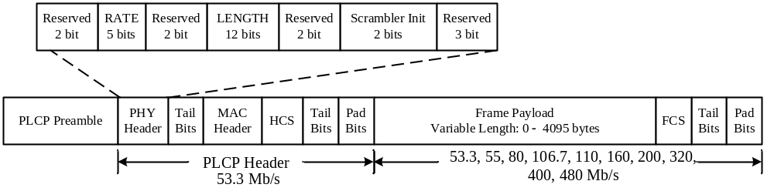

Figure 2 – PLCP frame format

The PLCP preamble is sent first, followed by the PLCP header, followed by an optional band extension sequence, followed by the frame payload, the FCS, the tail bits, and finally the pad bits. As shown in Figure 2, the PLCP header is always sent at an information data rate of 53.3 Mb/s. The remainder of the PLCP frame (frame payload, FCS, tail bits, and pad bits) is sent at the desired information data rate of 53.3, 55, 80, 106.7, 110, 160, 200, 320, 400 or 480 Mb/s.

RATE-dependent parameters

The data rate dependent modulation parameters are listed in Table 3.

Table 3 – Rate-dependent parameters
Data Rate (Mb/s) | Modulation | Coding  rate  (R) | Conjugate  Symmetric  Input to IFFT | Time  Spreading Factor | Overall  Spreading  Gain | Coded bits per OFDM symbol (N_{CBPS})
53.3 | QPSK | 1/3 | Yes | 2 | 4 | 100
55 | QPSK | 11/32 | Yes | 2 | 4 | 100
80 | QPSK | ½ | Yes | 2 | 4 | 100
106.7 | QPSK | 1/3 | No | 2 | 2 | 200
110 | QPSK | 11/32 | No | 2 | 2 | 200
160 | QPSK | ½ | No | 2 | 2 | 200
200 | QPSK | 5/8 | No | 2 | 2 | 200
320 | QPSK | ½ | No | 1 (No spreading) | 1 | 200
400 | QPSK | 5/8 | No | 1 (No spreading) | 1 | 200
480 | QPSK | ¾ | No | 1 (No spreading) | 1 | 200

Timing-related parameters

A list of the timing parameters associated with the OFDM PHY is listed in Table 4.

Table 4 – Timing-related parameters
Parameter | Value
N_{SD}: Number of data subcarriers | 100
N_{SDP}: Number of defined pilot carriers | 12
N_{SG}: Number of guard carriers | 10
N_{ST}: Number of total subcarriers used | 122 (= N_{SD} + N_{SDP} + N_{SG})
Δ_{F}: Subcarrier frequency spacing | 4.125 MHz (= 528 MHz/128)
T_{FFT}: IFFT/FFT period | 242.42 ns (1/Δ_{F})
T_{CP}: Cyclic prefix duration | 60.61 ns (= 32/528 MHz)
T_{GI}: Guard interval duration | 9.47 ns (= 5/528 MHz)
T_{SYM}: Symbol interval | 312.5 ns (T_{CP} + T_{FFT} + T_{GI})

PLCP preamble

In this section both the standard PLCP preamble as well as a shortened streaming mode PLCP preamble are defined. The preamble signals are real signals in the baseband, and are added to the real part of the complex baseband payload signal

A standard PLCP preamble shall be added prior to the PLCP header to aid receiver algorithms related to synchronization, carrier-offset recovery, and channel estimation. The standard PLCP preamble, which is shown in Figure 3, consists of three distinct portions: packet synchronization sequence, frame synchronization sequence, and the channel estimation sequence. The packet synchronization sequence shall be constructed by successively appending 21 periods, denoted as {PS₀, PS₁, …, PS₂₀}, of a time-domain sequence. Each time-domain sequence is associated with a particular time-frequency code. These time-domain sequences are defined in Table 5 through Table 8. Each period of the timing synchronization sequence shall be constructed by pre-appending 32 “zero samples” and by appending a guard interval of 5 “zero samples” to the sequences defined in Table 5 through Table 8. This portion of the preamble can be used for packet detection and acquisition, coarse carrier frequency estimation, and coarse symbol timing.

Similarly, the frame synchronization sequence shall be constructed by successively appending 3 periods, denoted as {FS₀, FS₁, FS₂}, of an 180 degree rotated version of the time-domain sequence specified in Table 5 through Table 8. Again, each period of the frame synchronization sequence shall be constructed by pre-appending 32 “zero samples” and by appending a guard interval of 5 “zero samples” to the sequences defined in Table 5 through Table 8. This portion of the preamble can be used to synchronize the receiver algorithm within the preamble.

Finally, the channel estimation sequence shall be constructed by successively appending 6 periods, denoted as {CE₀, CE₁, …, CE₅}, of the OFDM training symbol. This training symbol is generated by passing the frequency-domain sequence, defined in Table 9, though the IFFT, and pre-appending the output with 32 “zero samples” and appending and a guard interval consisting of 5 “zero samples” to the resulting time-domain output. This portion of the preamble can be used to estimate the channel frequency response, for fine carrier frequency estimation, and fine symbol timing.

N.B.:The time domain sequences in Tables 5-8 should be normalized appropriately in order to have the same average power as the signals which are defined in the frequency domain (and are thus passed through an IFFT operation), such as the channel estimation sequence defined in Table 9, and the payload signal.

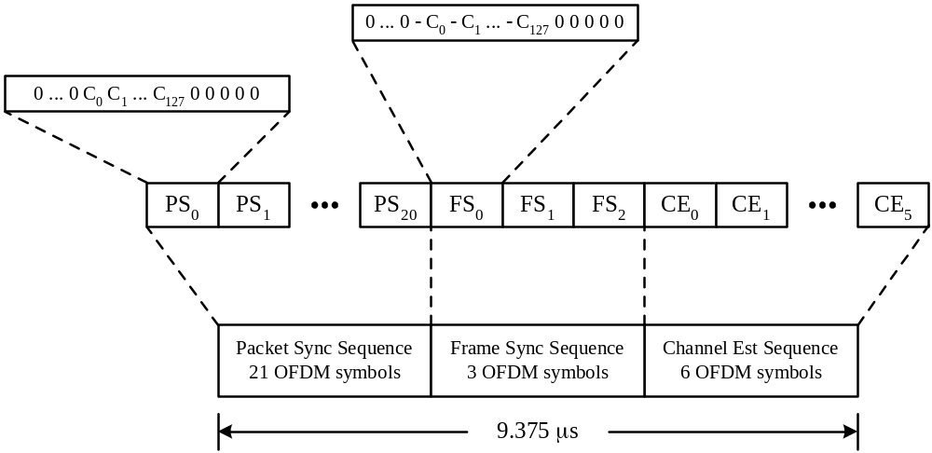
Figure 3 – Standard PLCP preamble format

In addition to a standard PLCP preamble, a streaming-mode PLCP preamble is also defined in this section. In the streaming packet mode, the first packet shall use the standard PLCP preamble, while the remaining packets (second packet and on), which are separated by a MIFS time, shall use the streaming-mode PLCP preamble instead of the standard PLCP preamble. The streaming-mode PLCP preamble, which is shown in Figure 4, consists of three distinct portions: packet synchronization sequence, frame synchronization sequence, and the channel estimation sequence. The packet synchronization sequence shall be constructed by successively appending 9 periods, denoted as {PS₀, PS₁, …, PS₈}, of a time-domain sequence. Each piconet will use a distinct time-domain sequence. These time-domain sequences are defined in Table 5 through Table 8. Each period of the timing synchronization sequence shall be constructed by pre-appending 32 “zero samples” and by appending a guard interval of 5 “zero samples” to the sequences defined in Table 5 through Table 8. This portion of the preamble can be used for packet detection and acquisition, coarse carrier frequency estimation, and coarse symbol timing.

Similarly, the frame synchronization sequence shall be constructed by successively appending 3 periods, denoted as {FS₀, FS₁, FS₂}, of an 180 degree rotated version of the time-domain sequence specified in Table 5 through Table 8. Again, each period of the frame synchronization sequence shall be constructed by pre-appending 32 “zero samples” and by appending a guard interval of 5 “zero samples” to the sequences defined in Table 5 through Table 8. This portion of the preamble can be used to synchronize the receiver algorithm within the preamble.

Finally, the channel estimation sequence shall be constructed by successively appending 6 periods, denoted as {CE₀, CE₁, …, CE₅}, of the OFDM training symbol. This training symbol is generated by passing the frequency-domain sequence, defined in Table 9, though the IFFT, and pre-appending the output with 32 “zero samples” and appending and a guard interval consisting of 5 “zero samples” to the resulting time-domain output. This portion of the preamble can be used to estimate the channel frequency response, for fine carrier frequency estimation, and fine symbol timing.

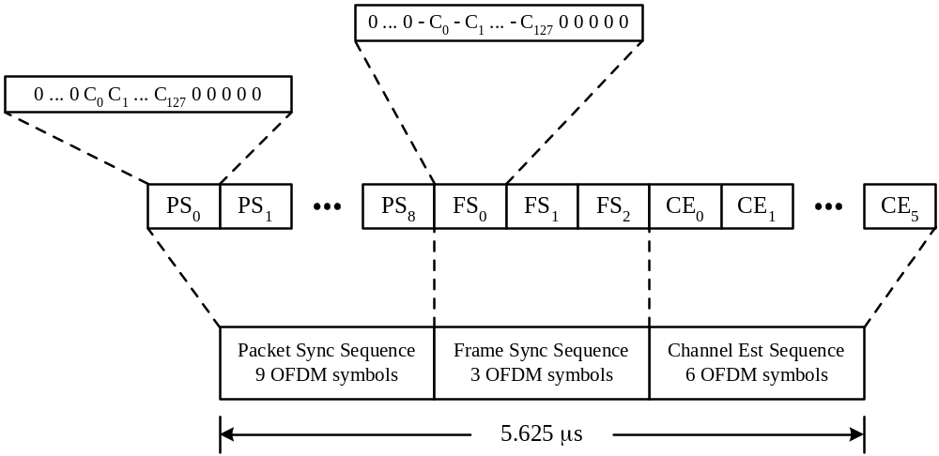
Figure 4 – Streaming-mode PLCP preamble format

Table 5 – Time-domain packet synchronization sequence for Preamble Pattern 1
Sequence Element | Value | Sequence Element | Value | Sequence Element | Value | Sequence Element | Value
C₀ | 0.6564 | C₃₂ | -0.0844 | C₆₄ | -0.2095 | C₉₆ | 0.4232
C₁ | -1.3671 | C₃₃ | 1.1974 | C₆₅ | 1.1640 | C₉₇ | -1.2684
C₂ | -0.9958 | C₃₄ | 1.2261 | C₆₆ | 1.2334 | C₉₈ | -1.8151
C₃ | -1.3981 | C₃₅ | 1.4401 | C₆₇ | 1.5338 | C₉₉ | -1.4829
C₄ | 0.8481 | C₃₆ | -0.5988 | C₆₈ | -0.8844 | C₁₀₀ | 1.0302
C₅ | 1.0892 | C₃₇ | -0.4675 | C₆₉ | -0.3857 | C₁₀₁ | 0.9419
C₆ | -0.8621 | C₃₈ | 0.8520 | C₇₀ | 0.7730 | C₁₀₂ | -1.1472
C₇ | 1.1512 | C₃₉ | -0.8922 | C₇₁ | -0.9754 | C₁₀₃ | 1.4858
C₈ | 0.9602 | C₄₀ | -0.5603 | C₇₂ | -0.2315 | C₁₀₄ | -0.6794
C₉ | -1.3581 | C₄₁ | 1.1886 | C₇₃ | 0.5579 | C₁₀₅ | 0.9573
C₁₀ | -0.8354 | C₄₂ | 1.1128 | C₇₄ | 0.4035 | C₁₀₆ | 1.0807
C₁₁ | -1.3249 | C₄₃ | 1.0833 | C₇₅ | 0.4248 | C₁₀₇ | 1.1445
C₁₂ | 1.0964 | C₄₄ | -0.9073 | C₇₆ | -0.3359 | C₁₀₈ | -1.2312
C₁₃ | 1.3334 | C₄₅ | -1.6227 | C₇₇ | -0.9914 | C₁₀₉ | -0.6643
C₁₄ | -0.7378 | C₄₆ | 1.0013 | C₇₈ | 0.5975 | C₁₁₀ | 0.3836
C₁₅ | 1.3565 | C₄₇ | -1.6067 | C₇₉ | -0.8408 | C₁₁₁ | -1.1482
C₁₆ | 0.9361 | C₄₈ | 0.3360 | C₈₀ | 0.3587 | C₁₁₂ | -0.0353
C₁₇ | -0.8212 | C₄₉ | -1.3136 | C₈₁ | -0.9604 | C₁₁₃ | -0.6747
C₁₈ | -0.2662 | C₅₀ | -1.4448 | C₈₂ | -1.0002 | C₁₁₄ | -1.1653
C₁₉ | -0.6866 | C₅₁ | -1.7238 | C₈₃ | -1.1636 | C₁₁₅ | -0.8896
C₂₀ | 0.8437 | C₅₂ | 1.0287 | C₈₄ | 0.9590 | C₁₁₆ | 0.2414
C₂₁ | 1.1237 | C₅₃ | 0.6100 | C₈₅ | 0.7137 | C₁₁₇ | 0.1160
C₂₂ | -0.3265 | C₅₄ | -0.9237 | C₈₆ | -0.6776 | C₁₁₈ | -0.6987
C₂₃ | 1.0511 | C₅₅ | 1.2618 | C₈₇ | 0.9824 | C₁₁₉ | 0.4781
C₂₄ | 0.7927 | C₅₆ | 0.5974 | C₈₈ | -0.5454 | C₁₂₀ | 0.1821
C₂₅ | -0.3363 | C₅₇ | -1.0976 | C₈₉ | 1.1022 | C₁₂₁ | -1.0672
C₂₆ | -0.1342 | C₅₈ | -0.9776 | C₉₀ | 1.6485 | C₁₂₂ | -0.9676
C₂₇ | -0.1546 | C₅₉ | -0.9982 | C₉₁ | 1.3307 | C₁₂₃ | -1.2321
C₂₈ | 0.6955 | C₆₀ | 0.8967 | C₉₂ | -1.2852 | C₁₂₄ | 0.5003
C₂₉ | 1.0608 | C₆₁ | 1.7640 | C₉₃ | -1.2659 | C₁₂₅ | 0.7419
C₃₀ | -0.1600 | C₆₂ | -1.0211 | C₉₄ | 0.9435 | C₁₂₆ | -0.8934
C₃₁ | 0.9442 | C₆₃ | 1.6913 | C₉₅ | -1.6809 | C₁₂₇ | 0.8391

Table 6 – Time-domain packet synchronization sequence for Preamble Pattern 2

Sequence Element | Value | Sequence Element | Value | Sequence Element | Value | Sequence Element | Value
C₀ | 0.9679 | C₃₂ | -1.2905 | C₆₄ | 1.5280 | C₉₆ | 0.5193
C₁ | -1.0186 | C₃₃ | 1.1040 | C₆₅ | -0.9193 | C₉₇ | -0.3439
C₂ | 0.4883 | C₃₄ | -1.2408 | C₆₆ | 1.1246 | C₉₈ | 0.1428
C₃ | 0.5432 | C₃₅ | -0.8062 | C₆₇ | 1.2622 | C₉₉ | 0.6251
C₄ | -1.4702 | C₃₆ | 1.5425 | C₆₈ | -1.4406 | C₁₀₀ | -1.0468
C₅ | -1.4507 | C₃₇ | 1.0955 | C₆₉ | -1.4929 | C₁₀₁ | -0.5798
C₆ | -1.1752 | C₃₈ | 1.4284 | C₇₀ | -1.1508 | C₁₀₂ | -0.8237
C₇ | -0.0730 | C₃₉ | -0.4593 | C₇₁ | 0.4126 | C₁₀₃ | 0.2667
C₈ | -1.2445 | C₄₀ | -1.0408 | C₇₂ | -1.0462 | C₁₀₄ | -0.9563
C₉ | 0.3143 | C₄₁ | 1.0542 | C₇₃ | 0.7232 | C₁₀₅ | 0.6016
C₁₀ | -1.3951 | C₄₂ | -0.4446 | C₇₄ | -1.1574 | C₁₀₆ | -0.9964
C₁₁ | -0.9694 | C₄₃ | -0.7929 | C₇₅ | -0.7102 | C₁₀₇ | -0.3541
C₁₂ | 0.4563 | C₄₄ | 1.6733 | C₇₆ | 0.8502 | C₁₀₈ | 0.3965
C₁₃ | 0.3073 | C₄₅ | 1.7568 | C₇₇ | 0.6260 | C₁₀₉ | 0.5201
C₁₄ | 0.6408 | C₄₆ | 1.3273 | C₇₈ | 0.9530 | C₁₁₀ | 0.4733
C₁₅ | -0.9798 | C₄₇ | -0.2465 | C₇₉ | -0.4971 | C₁₁₁ | -0.2362
C₁₆ | -1.4116 | C₄₈ | 1.6850 | C₈₀ | -0.8633 | C₁₁₂ | -0.6892
C₁₇ | 0.6038 | C₄₉ | -0.7091 | C₈₁ | 0.6910 | C₁₁₃ | 0.4787
C₁₈ | -1.3860 | C₅₀ | 1.1396 | C₈₂ | -0.3639 | C₁₁₄ | -0.2605
C₁₉ | -1.0888 | C₅₁ | 1.5114 | C₈₃ | -0.8874 | C₁₁₅ | -0.5887
C₂₀ | 1.1036 | C₅₂ | -1.4343 | C₈₄ | 1.5311 | C₁₁₆ | 0.9411
C₂₁ | 0.7067 | C₅₃ | -1.5005 | C₈₅ | 1.1546 | C₁₁₇ | 0.7364
C₂₂ | 1.1667 | C₅₄ | -1.2572 | C₈₆ | 1.1935 | C₁₁₈ | 0.6714
C₂₃ | -1.0225 | C₅₅ | 0.8274 | C₈₇ | -0.2930 | C₁₁₉ | -0.1746
C₂₄ | -1.2471 | C₅₆ | -1.5140 | C₈₈ | 1.3285 | C₁₂₀ | 1.1776
C₂₅ | 0.7788 | C₅₇ | 1.1421 | C₈₉ | -0.7231 | C₁₂₁ | -0.8803
C₂₆ | -1.2716 | C₅₈ | -1.0135 | C₉₀ | 1.2832 | C₁₂₂ | 1.2542
C₂₇ | -0.8745 | C₅₉ | -1.0657 | C₉₁ | 0.7878 | C₁₂₃ | 0.5111
C₂₈ | 1.2175 | C₆₀ | 1.4073 | C₉₂ | -0.8095 | C₁₂₄ | -0.8209
C₂₉ | 0.8419 | C₆₁ | 1.8196 | C₉₃ | -0.7463 | C₁₂₅ | -0.8975
C₃₀ | 1.2881 | C₆₂ | 1.1679 | C₉₄ | -0.8973 | C₁₂₆ | -0.9091
C₃₁ | -0.8210 | C₆₃ | -0.4131 | C₉₅ | 0.5560 | C₁₂₇ | 0.2562
Table 7 – Time-domain packet synchronization sequence for Preamble Pattern 3

Sequence Element | Value | Sequence Element | Value | Sequence Element | Value | Sequence Element | Value
C₀ | 0.4047 | C₃₂ | -0.9671 | C₆₄ | -0.7298 | C₉₆ | 0.2424
C₁ | 0.5799 | C₃₃ | -0.9819 | C₆₅ | -0.9662 | C₉₇ | 0.5703
C₂ | -0.3407 | C₃₄ | 0.7980 | C₆₆ | 0.9694 | C₉₈ | -0.6381
C₃ | 0.4343 | C₃₅ | -0.8158 | C₆₇ | -0.8053 | C₉₉ | 0.7861
C₄ | 0.0973 | C₃₆ | -0.9188 | C₆₈ | -0.9052 | C₁₀₀ | 0.9175
C₅ | -0.7637 | C₃₇ | 1.5146 | C₆₉ | 1.5933 | C₁₀₁ | -0.4595
C₆ | -0.6181 | C₃₈ | 0.8138 | C₇₀ | 0.8418 | C₁₀₂ | -0.2201
C₇ | -0.6539 | C₃₉ | 1.3773 | C₇₁ | 1.5363 | C₁₀₃ | -0.7755
C₈ | 0.3768 | C₄₀ | 0.2108 | C₇₂ | 0.3085 | C₁₀₄ | -0.2965
C₉ | 0.7241 | C₄₁ | 0.9245 | C₇₃ | 1.3016 | C₁₀₅ | -1.1220
C₁₀ | -1.2095 | C₄₂ | -1.2138 | C₇₄ | -1.5546 | C₁₀₆ | 1.7152
C₁₁ | 0.6027 | C₄₃ | 1.1252 | C₇₅ | 1.5347 | C₁₀₇ | -1.2756
C₁₂ | 0.4587 | C₄₄ | 0.9663 | C₇₆ | 1.0935 | C₁₀₈ | -0.7731
C₁₃ | -1.3879 | C₄₅ | -0.8418 | C₇₇ | -0.8978 | C₁₀₉ | 1.0724
C₁₄ | -1.0592 | C₄₆ | -0.6811 | C₇₈ | -0.9712 | C₁₁₀ | 1.1733
C₁₅ | -1.4052 | C₄₇ | -1.3003 | C₇₉ | -1.3763 | C₁₁₁ | 1.4711
C₁₆ | -0.8439 | C₄₈ | -0.3397 | C₈₀ | -0.6360 | C₁₁₂ | 0.4881
C₁₇ | -1.5992 | C₄₉ | -1.1051 | C₈₁ | -1.2947 | C₁₁₃ | 0.7528
C₁₈ | 1.1975 | C₅₀ | 1.2400 | C₈₂ | 1.6436 | C₁₁₄ | -0.6417
C₁₉ | -1.9525 | C₅₁ | -1.3975 | C₈₃ | -1.6564 | C₁₁₅ | 1.0363
C₂₀ | -1.5141 | C₅₂ | -0.7467 | C₈₄ | -1.1981 | C₁₁₆ | 0.8002
C₂₁ | 0.7219 | C₅₃ | 0.2706 | C₈₅ | 0.8719 | C₁₁₇ | -0.0077
C₂₂ | 0.6982 | C₅₄ | 0.7294 | C₈₆ | 0.9992 | C₁₁₈ | -0.2336
C₂₃ | 1.2924 | C₅₅ | 0.7444 | C₈₇ | 1.4872 | C₁₁₉ | -0.4653
C₂₄ | -0.9460 | C₅₆ | -0.3970 | C₈₈ | -0.4586 | C₁₂₀ | 0.6862
C₂₅ | -1.2407 | C₅₇ | -1.0718 | C₈₉ | -0.8404 | C₁₂₁ | 1.2716
C₂₆ | 0.4572 | C₅₈ | 0.6646 | C₉₀ | 0.6982 | C₁₂₂ | -0.8880
C₂₇ | -1.2151 | C₅₉ | -1.1037 | C₉₁ | -0.7959 | C₁₂₃ | 1.4011
C₂₈ | -0.9869 | C₆₀ | -0.5716 | C₉₂ | -0.5692 | C₁₂₄ | 0.9531
C₂₉ | 1.2792 | C₆₁ | 0.9001 | C₉₃ | 1.3528 | C₁₂₅ | -1.1210
C₃₀ | 0.6882 | C₆₂ | 0.7317 | C₉₄ | 0.9536 | C₁₂₆ | -0.9489
C₃₁ | 1.2586 | C₆₃ | 0.9846 | C₉₅ | 1.1784 | C₁₂₇ | -1.2566
Table 8 – Time-domain packet synchronization sequence for Preamble Pattern 4

Sequence Element | Value | Sequence Element | Value | Sequence Element | Value | Sequence Element | Value
C₀ | 1.1549 | C₃₂ | -1.2385 | C₆₄ | 1.3095 | C₉₆ | -1.0094
C₁ | 1.0079 | C₃₃ | -0.7883 | C₆₅ | 0.6675 | C₉₇ | -0.7598
C₂ | 0.7356 | C₃₄ | -0.7954 | C₆₆ | 1.2587 | C₉₈ | -1.0786
C₃ | -0.7434 | C₃₅ | 1.0874 | C₆₇ | -0.9993 | C₉₉ | 0.6699
C₄ | -1.3930 | C₃₆ | 1.1491 | C₆₈ | -1.0052 | C₁₀₀ | 0.9813
C₅ | 1.2818 | C₃₇ | -1.4780 | C₆₉ | 0.6601 | C₁₀₁ | -0.5563
C₆ | -1.1033 | C₃₈ | 0.8870 | C₇₀ | -1.0228 | C₁₀₂ | 1.0548
C₇ | -0.2523 | C₃₉ | 0.4694 | C₇₁ | -0.7489 | C₁₀₃ | 0.8925
C₈ | -0.7905 | C₄₀ | 1.5066 | C₇₂ | 0.5086 | C₁₀₄ | -1.3656
C₉ | -0.4261 | C₄₁ | 1.1266 | C₇₃ | 0.1563 | C₁₀₅ | -0.8472
C₁₀ | -0.9390 | C₄₂ | 0.9935 | C₇₄ | 0.0673 | C₁₀₆ | -1.3110
C₁₁ | 0.4345 | C₄₃ | -1.2462 | C₇₅ | -0.8375 | C₁₀₇ | 1.1897
C₁₂ | 0.4433 | C₄₄ | -1.7869 | C₇₆ | -1.0746 | C₁₀₈ | 1.5127
C₁₃ | -0.3076 | C₄₅ | 1.7462 | C₇₇ | 0.4454 | C₁₀₉ | -0.7474
C₁₄ | 0.5644 | C₄₆ | -1.4881 | C₇₈ | -0.7831 | C₁₁₀ | 1.4678
C₁₅ | 0.2571 | C₄₇ | -0.4090 | C₇₉ | -0.3623 | C₁₁₁ | 1.0295
C₁₆ | -1.0030 | C₄₈ | -1.4694 | C₈₀ | -1.3658 | C₁₁₂ | -0.9210
C₁₇ | -0.7820 | C₄₉ | -0.7923 | C₈₁ | -1.0854 | C₁₁₃ | -0.4784
C₁₈ | -0.4064 | C₅₀ | -1.4607 | C₈₂ | -1.4923 | C₁₁₄ | -0.5022
C₁₉ | 0.9034 | C₅₁ | 0.9113 | C₈₃ | 0.4233 | C₁₁₅ | 1.2153
C₂₀ | 1.5406 | C₅₂ | 0.8454 | C₈₄ | 0.6741 | C₁₁₆ | 1.5783
C₂₁ | -1.4613 | C₅₃ | -0.8866 | C₈₅ | -1.0157 | C₁₁₇ | -0.7718
C₂₂ | 1.2745 | C₅₄ | 0.8852 | C₈₆ | 0.8304 | C₁₁₈ | 1.2384
C₂₃ | 0.3715 | C₅₅ | 0.4918 | C₈₇ | 0.4878 | C₁₁₉ | 0.6695
C₂₄ | 1.8134 | C₅₆ | -0.6096 | C₈₈ | -1.4992 | C₁₂₀ | 0.8821
C₂₅ | 0.9438 | C₅₇ | -0.4321 | C₈₉ | -1.1884 | C₁₂₁ | 0.7807
C₂₆ | 1.3130 | C₅₈ | -0.1327 | C₉₀ | -1.4008 | C₁₂₂ | 1.0537
C₂₇ | -1.3070 | C₅₉ | 0.4953 | C₉₁ | 0.7795 | C₁₂₃ | -0.0791
C₂₈ | -1.3462 | C₆₀ | 0.9702 | C₉₂ | 1.2926 | C₁₂₄ | -0.2845
C₂₉ | 1.6868 | C₆₁ | -0.8667 | C₉₃ | -1.2049 | C₁₂₅ | 0.5790
C₃₀ | -1.2153 | C₆₂ | 0.6803 | C₉₄ | 1.2934 | C₁₂₆ | -0.4664
C₃₁ | -0.6778 | C₆₃ | -0.0244 | C₉₅ | 0.8123 | C₁₂₇ | -0.1097

Table 9 – Frequency-domain OFDM training sequence
Tone  Number | Value | Tone  Number | Value | Tone  Number | Value | Tone  Number | Value
-61 | 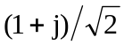 | -30 | 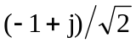 | 1 |  | 32
-60 | 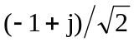 | -29 | 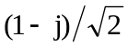 | 2 | 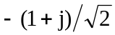 | 33
-59 |  | -28 |  | 3 |  | 34
-58 |  | -27 |  | 4 |  | 35
-57 |  | -26 |  | 5 |  | 36
-56 |  | -25 |  | 6 |  | 37
-55 |  | -24 |  | 7 |  | 38
-54 |  | -23 |  | 8 |  | 39
-53 |  | -22 |  | 9 |  | 40
-52 |  | -21 |  | 10 |  | 41
-51 |  | -20 |  | 11 |  | 42
-50 |  | -19 |  | 12 |  | 43
-49 |  | -18 |  | 13 |  | 44
-48 |  | -17 |  | 14 |  | 45
-47 |  | -16 |  | 15 |  | 46
-46 |  | -15 |  | 16 |  | 47
-45 |  | -14 |  | 17 |  | 48
-44 |  | -13 |  | 18 |  | 49
-43 |  | -12 |  | 19 |  | 50
-42 |  | -11 |  | 20 |  | 51
-41 |  | -10 |  | 21 |  | 52
-40 |  | -9 |  | 22 |  | 53
-39 |  | -8 |  | 23 |  | 54
-38 |  | -7 |  | 24 |  | 55
-37 |  | -6 |  | 25 |  | 56
-36 |  | -5 |  | 26 |  | 57 | 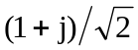
-35 |  | -4 |  | 27 |  | 58
-34 |  | -3 |  | 28 |  | 59 | 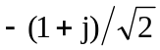
-33 |  | -2 |  | 29 |  | 60 | 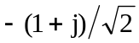
-32 |  | -1 |  | 30 |  | 61
-31 |  |  |  | 31

PHY header

The OFDM training symbols shall be followed by the PHY header, which contains the RATE of the MAC frame body, the length of the frame payload (which does not include the FCS), and the seed identifier for the data scrambler. The RATE field conveys the information about the type of modulation, the coding rate, and the spreading factor used to transmit the MAC frame body.

The PHY header field shall be composed of 28 bits, as illustrated in Figure 5. Bits 0–1 shall be reserved for future use. Bits 2–6 shall encode the RATE. Bits 7–8 shall be reserved for future use. Bits 9–20 shall encode the LENGTH field, with the least significant bit (LSB) being transmitted first. Bits 21–22 shall be reserved for future use. Bits 23–24 shall encode the initial state of the scrambler, which is used to synchronize the descrambler of the receiver. Bits 25–27 shall be reserved for future use.

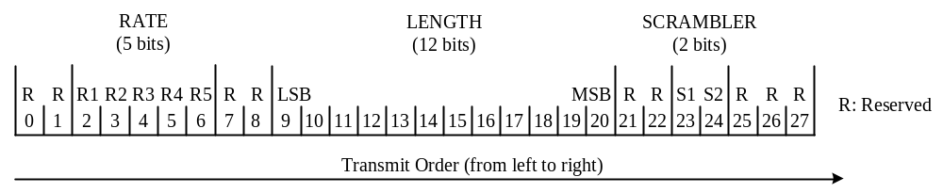
Figure 5 – PHY Header bit assignment

Date rate (RATE)

Depending on the information data rate (RATE), the bits R1–R5 shall be set according to the values in Table 10.

Table 10 – Rate-dependent parameters
Rate (Mb/s) | R1 – R5
53.3 | 00000
55 | 01000
80 | 00001
106.67 | 00010
110 | 01010
160 | 00011
200 | 00100
320 | 00101
400 | 00110
480 | 00111
Reserved | 01001, 01011–11111

PLCP length field (LENGTH)

The PLCP Length field shall be an unsigned 12-bit integer that indicates the number of octets in the frame payload (which does not include the FCS, the tail bits, or the pad bits).

PLCP scrambler field (SCRAMBLER)

The bits S1–S2 shall be set according to the scrambler seed identifier value. This two-bit value corresponds to the seed value chosen for the data scrambler.

Header modulation

The PHY header, MAC header, HCS, and tail bits shall be modulated using an information data rate of 55 Mb/s.

Data scrambler

A side-stream scrambler shall be used for the entire frame, except for the PLCP preamble and PHY header which shall not be scrambled. The polynomial generator, g(D), for the pseudo random binary sequence (PRBS) generator shall be g(D) = 1 + D¹⁴ + D¹⁵, where D is a single bit delay element. The polynomial not only forms a maximal length sequence, but is also a primitive polynomial. Using this generator polynomial, the corresponding PRBS, x_{n}, is generated as

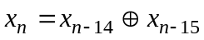

where “⊕” denotes modulo-2 addition. The following sequence defines the initialization vector, x_{init}, which is specified by the parameter “seed value” in Table 11.

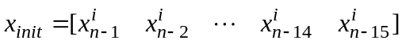

where 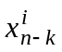represents the binary initial value at the output of the k^{th} delay element.

The scrambled data bits, s_{n}, are obtained as follows:

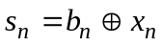

where b_{n} represents the unscrambled data bits. The side-stream de-scrambler at the receiver shall be initialized with the same initialization vector, x_{init}, used in the transmitter scrambler. The initialization vector is determined from the seed identifier contained in the PLCP header of the received frame.

The 15-bit initialization vector or seed value shall correspond to the seed identifier as shown in Table 11. The seed identifier value is set to 00 when the PHY is initialized and is incremented in a 2-bit rollover counter for each frame that is sent by the PHY. The value of the seed identifier that is used for the frame is sent in the PLCP header. The scrambler shall be reset at the end of the PLCP header using the same seed identifier as specified in the PLCP header before scrambling the frame body.

Table 11 – Scrambler seed selection
Seed identifier (b₁, b₀) | Seed value (x₁₄ … x₀)
0,0 | 0011 1111 1111 111
0,1 | 0111 1111 1111 111
1,0 | 1011 1111 1111 111
1,1 | 1111 1111 1111 111

Tail bits

The tail bit field shall be six bits of “0”, which are required to return the convolutional encoder to the “zero state”. This procedure improves the error probability of the convolutional decoder, which relies on the future bits when decoding the message stream. All tail bit fields (after the PHY header, after the HCS, and after the MAC frame payload) shall be produced by replacing the six scrambled bits with six “zero” bits.

Convolutional Encoder

The convolutional encoder shall use the rate R = 1/3 industry-standard generator polynomials, g₀ = 133₈, g₁ = 145₈, and g₂ = 175₈, as shown in Figure 6. The bit denoted as “A” shall be the first bit generated by the encoder, followed by the bit denoted as “B”, and finally, by the bit denoted as “C”. The various coding rates are derived from the rate R = 1/3 convolutional code by employing “puncturing”. Puncturing is a procedure for omitting some of the encoded bits in the transmitter (thus reducing the number of transmitted bits and increasing the coding rate) and inserting a dummy “zero” metric into the convolutional decoder on the receive side in place of the omitted bits. The puncturing patterns are illustrated in Figure 7 through Figure 10. In each of these cases, the tables shall be filled in with encoder output bits from the left to the right. For the last block of bits, the process shall be stopped at the point at which encoder output bits are exhausted, and the puncturing pattern applied to the partially filled block.

Decoding by the Viterbi algorithm is recommended.

The PLCP frame shall be encoded in the following manner. The PHY header, tail bits, MAC header, HCS, tail and pad bits shall be coded with a rate R = 11/32. The encoder shall be reset to the all-zero state following this. Next, the MAC frame body and tail bits shall be coded with a rate R = 11/32, 1/2, 5/8, or 3/4, corresponding to the desired data rate.

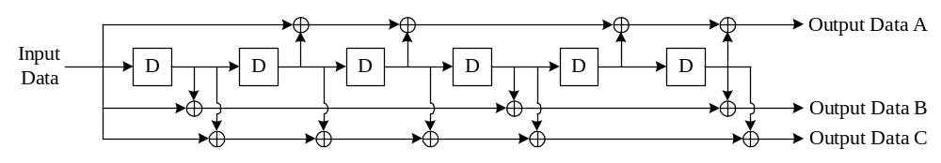

Figure 6 – Convolutional encoder: rate R = 1/3, constraint length K = 7

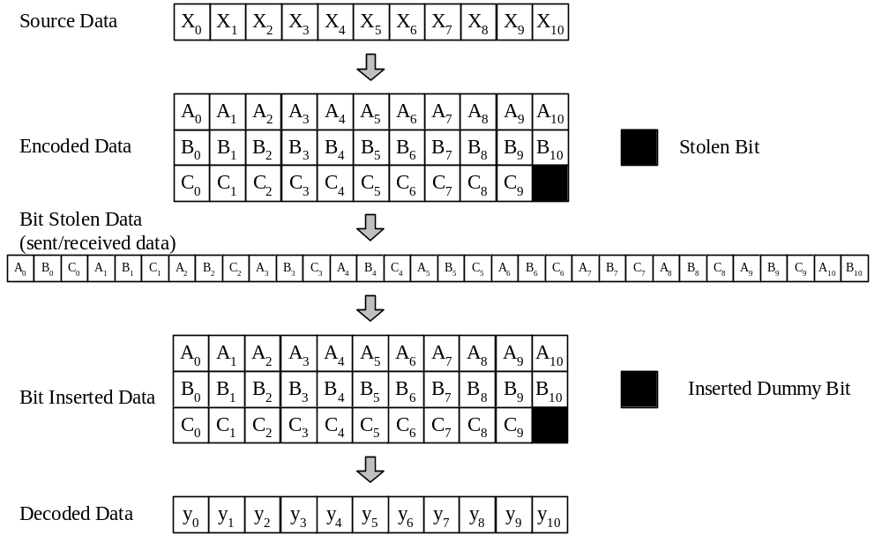

Figure 7 – An example of the bit-stealing and bit-insertion procedure (R = 11/32)

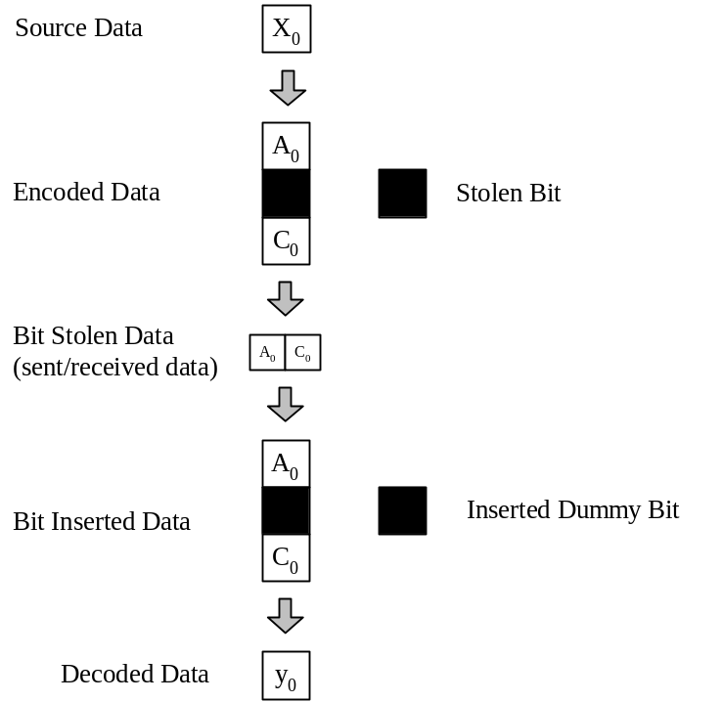

Figure 8 – An example of the bit-stealing and bit-insertion procedure (R = 1/2)

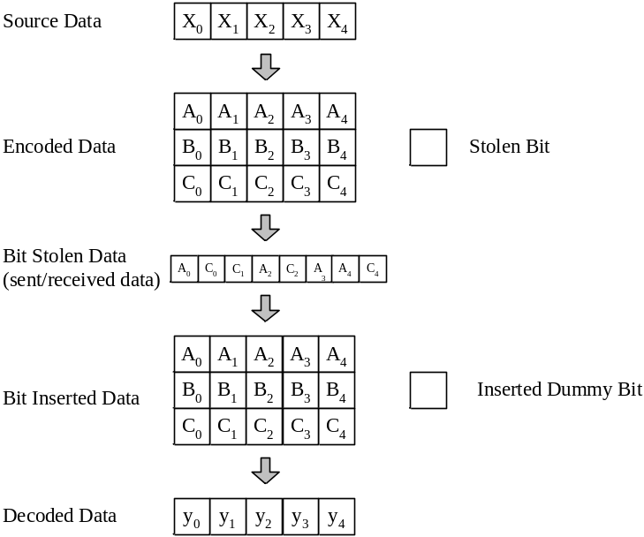
Figure 9 – An example of the bit-stealing and bit-insertion procedure (R = 5/8)
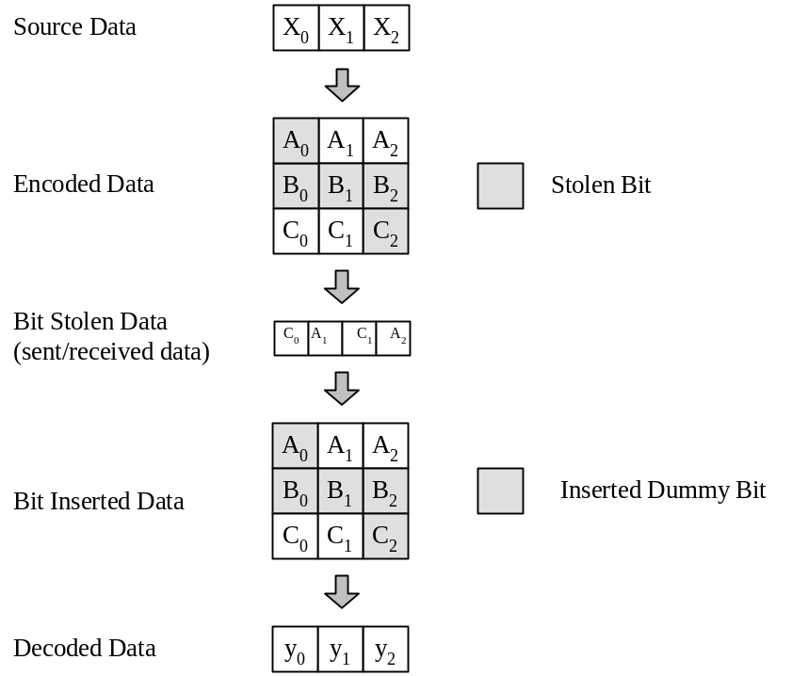

Figure 10– An example of the bit-stealing and bit-insertion procedure (R = 3/4)

Pad bits

Pad bits shall be appended to the end of the PLCP header and frame in order to ensure that the resulting frame boundaries are aligned with the boundaries of the OFDM symbol interleaver defined in 1.3.10. The number of pad bits that shall be inserted is a function of the code rate R and the number of bits in the frame payload (i.e., 8*(LENGTH)+FCS+tail bits). The number of OFDM symbols in the payload frame, N_{SYM}, is computed as follows:

N_{SYM} = Time_Spreading_Factor × 6× Ceiling [Ceiling [1/R × (8 × (LENGTH + FCS) + 6)] /(6×N_{CBPS})]

The function Ceiling (⋅) is a function that returns the smallest integer value greater than or equal to its argument value. The appended pad bits shall be set to “zeros” and subsequently scrambled with the rest of the bits.

Bit interleaving

The coded and padded bit stream is interleaved prior to modulation. Bit interleaving provides robustness against burst errors. The bit interleaving operation is performed in two stages: symbol interleaving followed by tone interleaving. The symbol interleaver permutes the bits across OFDM symbols to exploit frequency diversity across the sub-bands, while the tone interleaver permutes the bits across the data tones within an OFDM symbol to exploit frequency diversity across tones and provide robustness against narrow-band interferers. The symbol interleaver is constrained to interleave among 6N_{CBPS} coded bits, where N_{CBPS} is the number of coded bits per OFDM symbol.

For the bit interleaving operation, the coded bits shall first be grouped together into blocks of 6N_{CBPS} coded bits (corresponding to six OFDM symbols). Each group of coded bits shall then be permuted using a block interleaver of size N_{CBPS} × 6. Let the sequences {U(i)} and {S(i)}, where i = 0,…, 6N_{CBPS}−1, represent the input and output bits of the symbol block interleaver, respectively. The input-output relationship of this interleaver shall be given by:

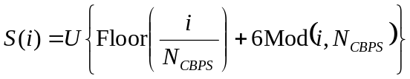,

where the function Floor(⋅) returns the largest integer value less than or equal to its argument value and where the function Mod(⋅) returns the remainder after division of i by N_{CBPS}.

The output of the symbol block interleaver is then passed through a tone block interleaver. The outputs of the symbol block interleaver after grouped together into blocks of N_{CBPS} bits and then permuted using a regular block interleaver of size N_{Tint} × 10, where N_{Tint} = N_{CBPS}/10. Let the sequences {S(i)} and {V(j)}, where i, j = 0,…, N_{CBPS}−1, represent the input and output bits of the tone interleaver, respectively. The input-output relationship of the tone block interleaver is given by:

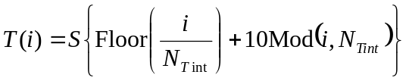,

where the function Mod(⋅) returns the remainder after division of N_{Tint} by i.

Subcarrier constellation mapping

The OFDM subcarriers shall be modulated using QPSK modulation. The encoded and interleaved binary serial input data shall be divided into groups of 2 bits and converted into complex numbers representing QPSK constellation points. The conversion shall be performed according to the Gray-coded constellation mappings, illustrated in Figure 11, with the input bit, b₀, being the earliest in the stream. The output values, d, are formed by multiplying the resulting (I + jQ) value by a normalization factor of K_{MOD}, as described in the following equation:

d = (I + jQ) × K_{MOD}.

The normalization factor, KMOD, depends on the base modulation mode, as prescribed in Table 12. In practical implementations, an approximate value of the normalization factor can be used, as long as the device conforms to the modulation accuracy requirements.

For QPSK, b₀ determines the I value and b₁ determines the Q value, as illustrated in Table 13.

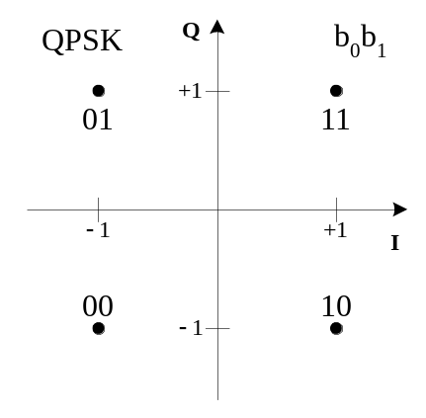

Figure 11 – QPSK constellation bit encoding

Table 12 – Modulation-dependent normalization factor K_{MOD}
Modulation | K_{MOD}
QPSK | 1/√2

Table 13 – QPSK encoding table
Input bit (b₀ b₁) | I-out | Q-out
00 | -1 | -1
01 | -1 | 1
10 | 1 | -1
11 | 1 | 1

OFDM modulation

For information data rates of 50, and 80 Mb/s, the stream of complex numbers is divided into groups of 50 complex numbers. We shall denote these complex numbers c_{n,k}, which corresponds to subcarrier n of OFDM symbol k, as follows:

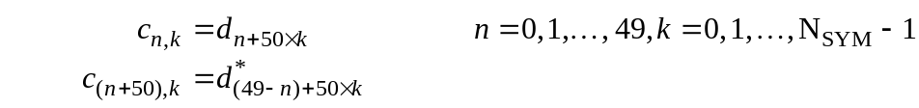

where N_{SYM} denotes the number of OFDM symbols in the MAC frame body, tail bits, and pad bits.

For information data rates of 110, 160, 200, 320 and 480 Mb/s, the stream of complex numbers is divided into groups of 100 complex numbers. We shall denote these complex numbers c_{n,k}, which corresponds to subcarrier n of OFDM symbol k, as follows:

where N_{SYM} denotes the number of OFDM symbols in the MAC frame body, tail bits, and pad bits.

An OFDM symbol r_{data,k}(t) is defined as

where N_{SD} is the number of data subcarriers, N_{ST} is the number of total subcarriers, and the function M(n) defines a mapping from the indices 0 to 99 to the logical frequency offset indices –56 to 56, excluding the locations reserved for the pilot subcarriers, guard subcarriers and the DC subcarrier (as described below):

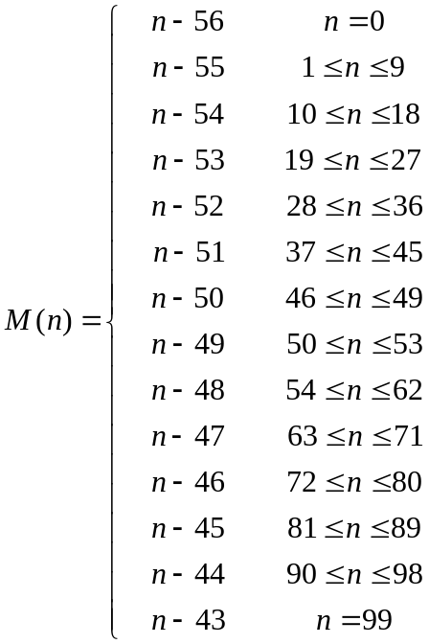

The subcarrier frequency allocation is shown in Figure 12. To avoid difficulties in DAC and ADC offsets and carrier feed-through in the RF system, the subcarrier falling at DC (0th subcarrier) is not used.

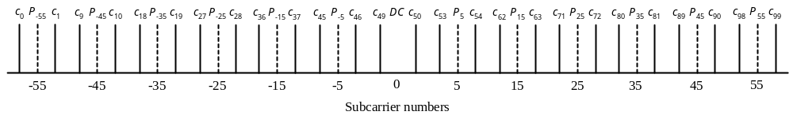

Figure 12 – Subcarrier frequency allocation

Pilot subcarriers

In each OFDM symbol, twelve of the subcarriers are dedicated to pilot signals in order to make coherent detection robust against frequency offsets and phase noise. These pilot signals shall be put in subcarriers numbered –55, –45, –35, –25, –15 –5, 5, 15, 25, 35, 45, and 55. The contribution due to the pilot subcarriers for the k^{th} OFDM symbol is given by the inverse Fourier Transform of the sequence P_{n} below, which is further BPSK modulated by a pseudo-random binary sequence, p_{l} (defined further below), to prevent the generation of spectral lines.

P_{n} = 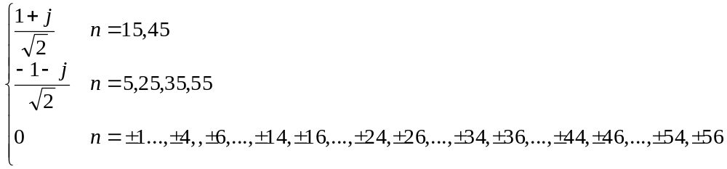

For modes with data rates less than 106.67 Mbps:
For 106.67 Mbps and all higher rate modes:

The polarity of the pilot subcarriers is controlled by the following pseudo-random LFSR sequence, p_{l}:

p_{0…126} = {1, 1, 1, 1, -1, -1, -1, 1, -1, -1, -1, -1, 1, 1, -1, 1, -1, -1, 1, 1, -1, 1, 1, -1, 1, 1, 1, 1, 1, 1, -1, 1, 1, 1, -1, 1, 1, -1, -1, 1, 1, 1, -1, 1, -1, -1, -1, 1, -1, 1, -1, -1, 1, -1, -1, 1, 1, 1, 1, 1, -1, -1, 1, 1, -1, -1, 1, -1, 1, -1, 1, 1, -1, -1, -1, 1, 1, -1, -1, -1, -1, 1, -1, -1, 1, -1, 1, 1, 1, 1, -1, 1, -1, 1, -1, 1, -1, -1, -1, -1, -1, 1, -1, 1, 1, -1, 1, -1, 1, 1, 1, -1, -1, 1, -1, -1, -1, 1, 1, 1, -1, -1, -1, -1, -1, -1, -1}.

Only one element of this sequence is used for an OFDM symbol.

Guard subcarriers

In each OFDM symbol ten subcarriers are dedicated to guard subcarriers or guard tones. The guard subcarriers can be used for various purposes, including relaxing the specs on transmit and receive filters. The magnitude level of the guard tones is not specified other than the definition below, and implementations can use reduced power for these subcarriers if desired. The guard subcarriers shall be located in subcarriers –61, –60,…, –57, and 57, 58, …, 61. The same linear-feedback shift register (LFSR) sequence, p_{l}, that is used to scramble the pilot subcarriers shall be used to generate the modulating data for the guard subcarriers. The guard subcarrier symbol definition for the n^{th} subcarrier of the k^{th} symbol is given as follows:
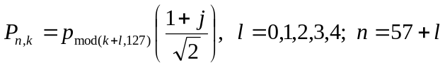
For modes with data rates less than 106.67 Mbps:
For 106.67 Mbps and all higher rate modes:
In this numbering, k=0 shall correspond to the first OFDM symbol following the PLCP preamble (i.e., the first OFDM symbol following the channel estimation symbols CE0-CE5). The elements from the sequence, p_{l}, shall be selected independently for the pilots and the guard subcarriers in this section.

Time-domain Spreading

For data rates of 55, 80, 110, 160 and 200 Mbps a time-domain spreading operation is performed with a spreading factor of 2. The time-domain spreading operation consists of transmitting the same information over two OFDM symbols. These two OFDM symbols are transmitted over different sub-bands to obtain frequency diversity. For example, if the device uses a time-frequency code [1 2 3 1 2 3], as specified in Table 15, the information in the first OFDM symbol is repeated on sub-bands 1 and 2, the information in the second OFDM symbol is repeated on sub-bands 3 and 1, and the information in the third OFDM symbol is repeated on sub-bands 2 and 3.

General requirements

Operating band frequencies

Operating frequency range

This PHY operates in the 3.1 – 10.6 GHz frequency as regulated in the United States by the Code of Federal Regulations, Title 47, Section 15, as well as in any other areas that the regulatory bodies have also allocated this band.

Band numbering

The relationship between center frequency and band number is given by the following equation:

Band center frequency = 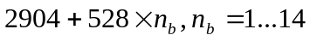(MHz).

This definition provides a unique numbering system for all channels that have a spacing of 528 MHz and lie within the band 3.1 – 10.6 GHz. Based on this, five band groups are defined, consisting of four groups of three bands each and one group of two bands. Band group 1 is used for Mode 1 devices (mandatory mode). The remaining band groups are reserved for future use. The band allocation is summarized in Table 14.

Table 14 – OFDM PHY band allocation
Band Group | BAND_ID | Lower frequency | Center frequency | Upper frequency
1 | 1 | 3168 MHz | 3432 MHz | 3696 MHz
1 | 2 | 3696 MHz | 3960 MHz | 4224 MHz
1 | 3 | 4224 MHz | 4488 MHz | 4752 MHz
2 | 4 | 4752 MHz | 5016 MHz | 5280 MHz
2 | 5 | 5280 MHz | 5544 MHz | 5808 MHz
2 | 6 | 5808 MHz | 6072 MHz | 6336 MHz
3 | 7 | 6336 MHz | 6600 MHz | 6864 MHz
3 | 8 | 6864 MHz | 7128 MHz | 7392 MHz
3 | 9 | 7392 MHz | 7656 MHz | 7920 MHz
4 | 10 | 7920 MHz | 8184 MHz | 8448 MHz
4 | 11 | 8448 MHz | 8712 MHz | 8976 MHz
4 | 12 | 8976 MHz | 9240 MHz | 9504 MHz
5 | 13 | 9504 MHz | 9768 MHz | 10032 MHz
5 | 14 | 10032 MHz | 10296 MHz | 10560 MHz

The frequency of operation for Mode 1 devices is shown in Figure 13.

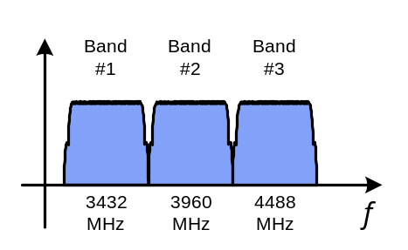
Figure 13 – Frequency of operation for a Mode 1 device.

Channelization

Unique logical channels corresponding to different piconets are defined by using upto four different time-frequency codes for each band group. Different preamble patterns are used in conjunction with the different time-frequency codes, as defined in 1.3.3. The time-frequency codes and associated preamble patterns for Mode 1 devices (which operate in band group 1) are defined in Table 15.

Table 15 – Time Frequency Codes and Preamble Patterns for Different Piconets (Mode 1)

Channel Number | Preamble Pattern | Mode 1: Length 6 Time Frequency Code
1 | 1 | 1 | 2 | 3 | 1 | 2 | 3
2 | 2 | 1 | 3 | 2 | 1 | 3 | 2
3 | 3 | 1 | 1 | 2 | 2 | 3 | 3
4 | 4 | 1 | 1 | 3 | 3 | 2 | 2

PHY layer timing

The values for the PHY layer timing parameters are defined in Table 16.

Table 16 – PHY layer timing parameters
PHY Parameter | Value
pMIFSTime | 6*T_{SYM} = 1.875 μs
pSIFSTime | 32*T_{SYM} = 10 μs
pCCADetectTime | 15*T_{SYM} = 4.6875 μs
pChannelSwitchTime | 9.0 ns

Interframe spacing

A conformant implementation shall support the interframe spacing parameters given in Table 17.

Table 17 – Interframe spacing parameters
802.15.3 MAC Parameter | Corresponding PHY Parameter
MIFS | pMIFSTime
SIFS | pSIFSTime
pBackoffSlot | pSIFSTime + pCCADetectTime
BIFS | pSIFSTime + pCCADetectTime
RIFS | 2*pSIFSTime + pCCADetectTime

Receive-to-transmit turnaround time

The RX-to-TX turnaround time shall be pSIFSTime. This turnaround time shall be measured at the air interface from the trailing edge of the last received OFDM symbol to the leading edge of the first transmitted OFDM symbol of the PLCP preamble for the next frame.

Transmit-to-receive turnaround time

The TX-to-RX turnaround time shall be pSIFSTime. This turnaround time shall be measured at the air interface from the trailing edge of the last transmitted symbol until the receiver is ready to begin the reception of the next PHY frame.

Time between successive transmissions

The time between uninterrupted successive transmissions by the same DEV shall be pMIFSTime. This time shall be measured at the air interface from the trailing edge of the last OFDM symbol transmitted to the leading edge of the first OFDM symbol of the PLCP preamble for the following frame.

Channel switch time

The channel switch time is defined as the interval from when the trailing edge of the last valid OFDM symbol is on air until the PHY is ready to transmit or receive from the air another OFDM symbol on a new channel. The channel switch time shall not exceed pChannelSwitchTime.

Header check sequence

The combined PLCP and MAC headers shall be protected with a CCITT CRC-16 header check sequence (HCS). The PHY parameter, pLengthHCS shall be 2 for this PHY. The CCITT CRC-16 HCS shall be the ones complement of the remainder generated by the modulo-2 division of the protected combined PLCP and MAC headers by the polynomial: 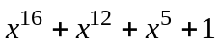. The protected bits shall be processed in the transmit order. All HCS calculations shall be made prior to data scrambling. A schematic of the processing order is shown in Figure 14.

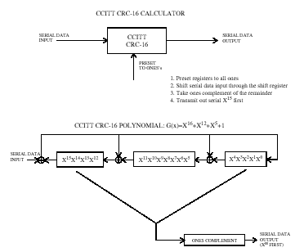

Figure 14 – CCITT CRC-16 Implementation

The CRC-16 described in this subclause is the same one used in the IEEE 802.15.3 draft standard.

Transmitter specifications

Transmit PSD mask

The transmitted spectrum shall have a 0 dBr (dB relative to the maximum spectral density of the signal) bandwidth not exceeding 260 MHz, –12 dBr at 285 MHz frequency offset, and –20 dBr at 330 MHz frequency offset and above. The transmitted spectral density of the transmitted signal mask shall fall within the spectral, as shown in Figure 15.

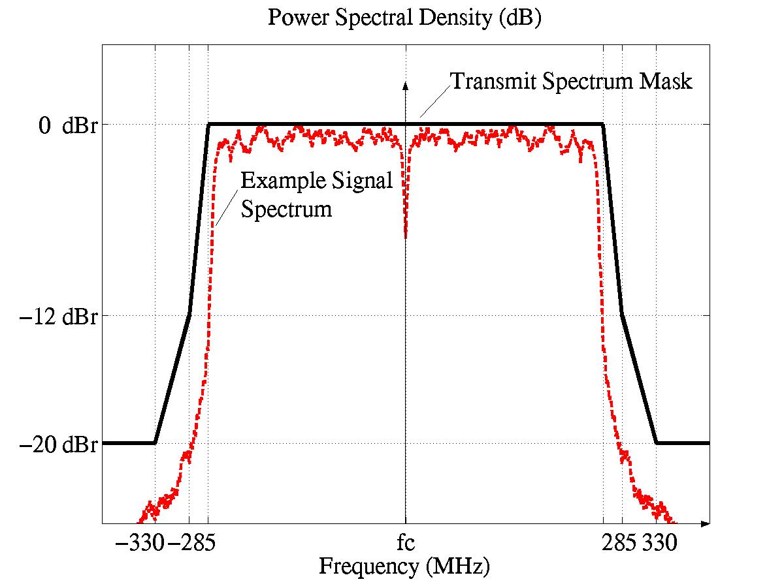

Figure 15 – Transmit Power Spectral Density Mask

Transmit center frequency tolerance

The transmitted center frequency tolerance shall be ±20 ppm maximum.

Symbol clock frequency tolerance

The symbol clock frequency tolerance shall be ±20 ppm maximum.

Clock synchronization

The transmit center frequency and the symbol clock frequency shall be derived from the same reference oscillator.

Receiver specification

Receiver sensitivity

For a packet error rate (PER) of less than 8% with a PSDU of 1024 bytes, the minimum receiver sensitivity numbers for the various rates and modes are listed in Table 18.

Table 18 – Receiver performance requirements
Data rate (Mb/s) | Minimum sensitivity (dBm) for Mode 1
55 | −83.5
80 | −81.7
110 | −80.5
160 | −78.7
200 | −77.2
320 | −75.1
480 | −72.7

Receiver CCA performance

The start of a valid OFDM transmission at a receiver level equal to or greater than the minimum 55 Mb/s sensitivity (−83.5 dBm) shall cause CCA to indicate busy with a probability > 90% within 4.6875 μs. If the preamble portion was missed, the receiver shall hold the carrier sense (CS) signal busy for any signal 20 dB above the minimum 55 Mb/s sensitivity (−63.5 dBm).

Self evaluation matrix

General solution criteria

 | REF. | IMPORTANCE  LEVEL | PROPOSER RESPONSE
Unit Manufacturing Complexity (UMC) | 3.1 | B | +
Signal Robustness
Interference And Susceptibility | 3.2.2 | A | +
Coexistence | 3.2.3 | A | +
Technical Feasibility
Manufacturability | 3.3.1 | A | +
Time To Market | 3.3.2 | A | +
Regulatory Impact | 3.3.3 | A | +
Scalability (i.e. Payload Bit Rate/Data Throughput, Channelization – physical or coded, Complexity, Range, Frequencies of Operation, Bandwidth of Operation, Power Consumption) | 3.4 | A | +
Location Awareness | 3.5 | C | +

PHY protocol criteria

CRITERIA | REF. | IMPORTANCE  LEVEL | PROPOSER RESPONSE
Size And Form Factor | 5.1 | B | +
PHY-SAP Payload Bit Rate & Data Throughput
Payload Bit Rate | 5.2.1 | A | +
Packet Overhead | 5.2.2 | A | +
PHY-SAP Throughput | 5.2.3 | A | +
Simultaneously Operating Piconets | 5.3 | A | +
Signal Acquisition | 5.4 | A | +
System Performance | 5.5 | A | +
Link Budget | 5.6 | A | +
Sensitivity | 5.7 | A | +
Power Management Modes | 5.8 | B | +
Power Consumption | 5.9 | A | +
Antenna Practicality | 5.10 | B | +

MAC protocol enhancement criteria

CRITERIA | REF. | IMPORTANCE  LEVEL | PROPOSER RESPONSE
MAC Enhancements And Modifications | 4.1. | C | +

Detailed responses to selection criteria and self-evaluation matrix

Unit manufacturing cost

The total die size for the PHY solution is expected to be around 4.9 mm² for Mode 1 devices, with 3.0 mm² for the analog/RF portion and 1.9 mm² for the digital portion. These estimates assume a 90 nm CMOS technology node in 2004. If a 130 nm CMOS technology node is assumed, the total die size of the PHY solution for Mode 1 devices is expected to be around 7.1 mm², with 3.3 mm² for the analog/RF portion and 3.8 mm² for the digital potion. The digital portion of the PHY is expected to require 295K gates. The enhancements to the MAC are not expected to affect the die size or gate count of the MAC. The major external components that will be required by the complete solution (RF+PHY+MAC) are a pre-select filter, balun, crystal oscillator, voltage regulator, and SRAM for the MAC..

Signal robustness

Interference and susceptibility

The receiver consists of a front-end pre-select filter to reject out-of band noise and interference. For the three-band Multi-band OFDM system (Mode 1) presented in this proposal, the pass-band of the pre-select filter is between 3168 MHz to 4752 MHz. The output of the pre-select filter is amplified using an LNA and is followed by down-conversion to the base-band using the appropriate center frequency. The base-band signal is filtered using a 3rd order low-pass filter.

The interference and susceptibility analysis are presented for Mode 1 devices that is assumed to be operating at 6 dB above the receiver sensitivity, namely P_{d} = –74.5 dBm (see Section 5.6), for an information data rate of 110 Mbps. Based on the link budget table of Section 5.6, the average noise power per bit is –87 dBm. Since a margin of 6 dB is available, the sum of the interferer-and-noise power can be at most –81 dBm to maintain a PER < 8% for a 1024 byte packet. Under the assumption that the impact of the interferer is similar to that of additive noise, this corresponds to a maximum tolerable interferer power of –82.3 dBm at the input of the decoder. The interference and susceptibility analysis for the following types of interferers has been provided in Table 19:

- Microwave oven

- IEEE 802.15.1 (Bluetooth)

- IEEE 802.11b

- IEEE 802.15.3

- IEEE 802.11a

- IEEE 802.15.4

Table 19 – Interference and Susceptibility Analysis

 | Microwave Oven | Bluetooth & IEEE 802.15.1 Interferer | IEEE 802.11b & IEEE 802.15.3 Interferer | IEEE 802.11a Interferer | IEEE 802.15.4 Interferer (2.45 GHz)
Max. tolerable interferer power at the encoder | -82.3 dBm | -82.3 dBm | -82.3 dBm | -82.3 dBm | -82.3 dBm
Processing gain (coding rate of 11/32) | 4.6 dB | 4.6 dB | 4.6 dB | 4.6 dB | 4.6 dB
Minimum base-band filter attenuation | 35.4 dB | 36.9 dB | 36.9 dB | 30.7 dB | 35.6 dB
Front-end pre-select filter attenuation | 35 dB | 35 dB | 35 dB | 30 dB | 35 dB
Max. tolerable interferer power at the antenna | -7.3 dB | -5.8 dB | -5.8 dB | -17 dB | -7.1 dB
Interferer power at 1m separation | -23.2 dBm | -40 dBm | -20 dBm | -31.9 dBm | -40.2 dBm
Minimum margin | 15.9 dB | 34.2 dB | 14.2 dB | 14.1 dB | 33.1 dB
Tolerable separation | ≅ 0.16 m | ≅ 0.02 m | ≅ 0.2 m | ≅ 0.2 m | ≅ 0.02 m

Microwave oven

The microwave oven is an out-of-band interferer and based on the analysis presented in Table 19, the Multi-band OFDM system can tolerate this interferer at a minimum separation of 0.16 m.

Bluetooth and IEEE 802.15.1 interferer

This is an out-of-band interferer and based on the analysis presented in Table 19, the Multi-band OFDM system can tolerate this interferer at a minimum separation of 0.02 m.

IEEE 802.11b and IEEE 802.15.3 interferer

This is an out-of-band interferer and based on the analysis presented in Table 19, the Multi-band OFDM system can tolerate this interferer at a minimum separation of 0.2 m. This interference tolerance is superior to the desired criteria of 0.3 m separation between the IEEE 802.11b interferer and the UWB reference device.

IEEE 802.11a interferer

As the Multi-band OFDM system only utilizes the spectrum between 3168 MHz and 4752 MHz, the IEEE 802.11a interferer is an out-of-band interferer. Hence, it is easier to design the front-end pre-select filter to reject the 802.11a interference. Based on the analysis presented in Table 19, the Multi-band OFDM system can tolerate this interferer at a minimum separation of at least 0.2 m. This interference tolerance is superior to the desired criteria of 0.3 m separation between the IEEE 802.11a interferer and the UWB reference device.

IEEE 802.15.4 interferer

This is an out-of-band interferer and the Multi-band OFDM system can tolerate this interferer at a minimum separation of 0.02 m. The analysis presented in Table 19 is only for the IEEE 802.15.4 interferer centered around 2.45 GHz. Although, the 802.15.4 device centered around 868 MHz and 915 MHz can have a receive power that is approximately 9 dB higher than that of the 802.15.4 device centered around 2.45 GHz, the base-band filter attenuation for these frequencies is significantly higher, and hence the 802.15.4 device with a center frequency of 2.45 GHz is the worst-case interferer.

Generic in-band modulated interferer

The robustness of the Multi-band OFDM system to the presence of a generic in-band modulated interferer was evaluated for Mode 1 devices based on AWGN simulations that incorporate losses due to front-end filtering, clipping at the DAC, ADC degradation (4-bits for 110/200 Mbps), packet acquisition, channel estimation, clock frequency mismatch (± 20 ppm at the TX and RX), carrier offset recovery, carrier tracking, etc. The center frequency of the interferer was swept uniformly from 3254 MHz to 4704 MHz in uniform steps of 50 MHz. Since the symbol rate of the modulated interferer is only 5 MHz, it will interfere with only a couple of tones. The affected tones can be erased to combat the narrow-band interferer and erasure of these tones results in some performance degradation. One of the advantages of the Multi-band OFDM system is that the sub-band in which the narrow band interferer is present can still be used with minimal impact. When operating at 6 dB above sensitivity for the 110 Mbps data rates, it was observed that the Multi-band OFDM system can tolerate a generic in-band modulated interferer with a power of P_{I} > P_{d} – 9.0 dB. The packet error rate performance of the Multi-band OFDM system in the presence of an in-band modulated interferer is illustrated in Figure 16.

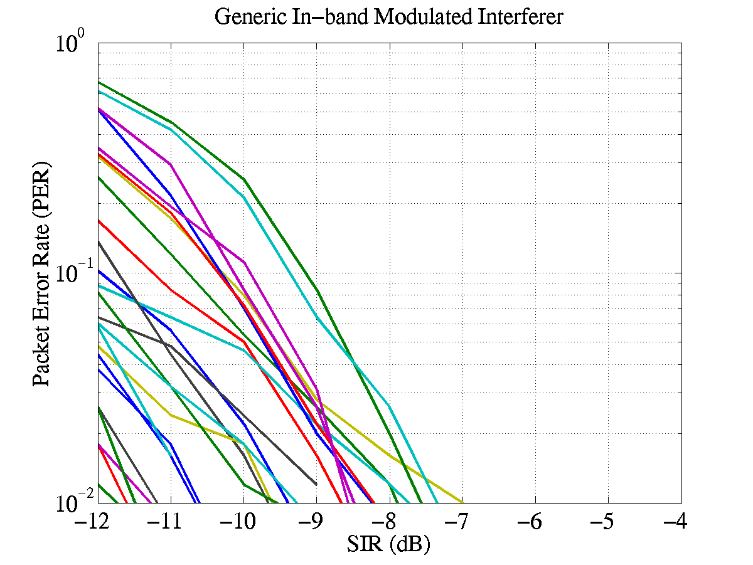
Figure 16: PER performance in the presence of a generic in-band modulated interferer

Generic in-band tone interferer

The robustness of the Multi-band OFDM system to the presence of a generic in-band tone interferer was evaluated for Mode 1 devices based on AWGN simulations that incorporate losses due to front-end filtering, clipping at the DAC, ADC degradation (4-bits for 110/200 Mbps), packet acquisition, channel estimation, clock frequency mismatch (± 20 ppm at the TX and RX), carrier offset recovery, carrier tracking, etc. A generic in-band tone interferer will affect at most two tones in any OFDM symbol. The affected tones can be erased to combat the narrow-band interferer and erasure of these tones results in some performance degradation. Hence, the sub-band in which the narrow band interferer is present can still be used with minimal impact. When operating at 6 dB above sensitivity, for the 110 Mbps data rates, it was observed that the Multi-band OFDM system can tolerate a generic in-band tone interferer with a power of P_{I} > P_{d} –8.0 dB. The packet error rate performance of the Multi-band OFDM system in the presence of an in-band modulated interferer is illustrated in Figure 17.
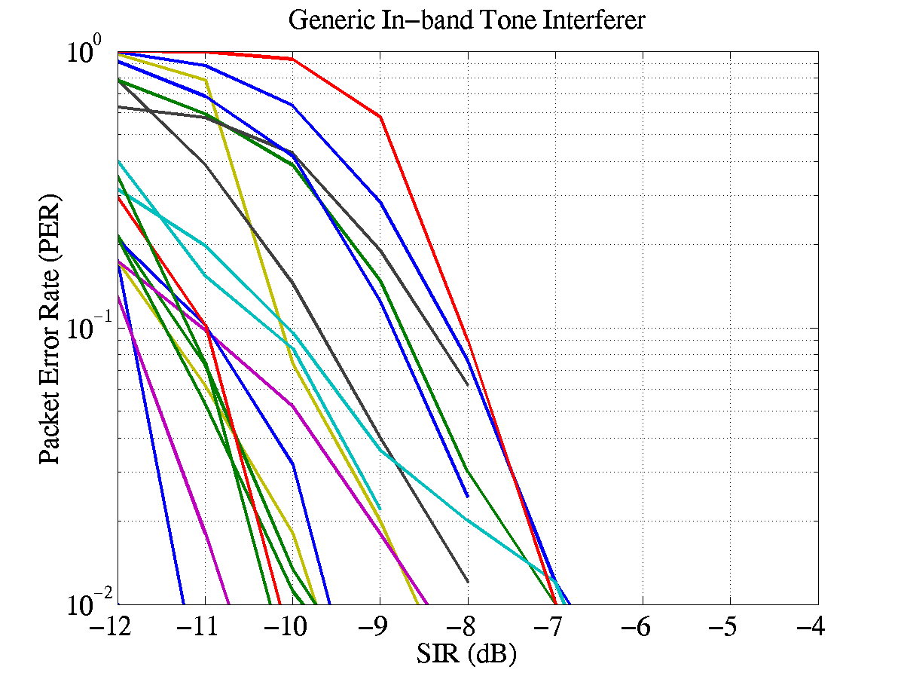
Figure 17: PER performance in the presence of a generic in-band tone interferer

Out-of-band interference from intentional and unintentional radiators

The minimum out-of-band rejection (in dB) provided by the Multi-band OFDM is listed in Table 20 for various center frequencies for Mode 1 devices.

Table 20 – Minimum out-of-band rejection for Multi-band OFDM
Center Frequency | Pre-select Filter Attenuation | Base-band Filter Attenuation | Total Attenuation
900 MHz | 35 dB | 60 dB | 95 dB
1900 MHz | 35 dB | 47 dB | 82 dB
2450 MHz | 35 dB | 35 dB | 70 dB
5150 MHz | 25 dB | 25 dB | 50 dB
5300 MHz | 30 dB | 30 dB | 60 dB
5850 MHz | 35 dB | 44 dB | 79 dB

Coexistence

The Multi-band OFDM system is very coexistence friendly. Firstly, for the proposed system employing three sub-bands, all the victim receivers specified in the selection criteria document are essentially out-of-band. Hence, the impact of the Multi-band OFDM system on these devices will be minimal, if any. Secondly, the Multi-band OFDM system offers an enhanced level of co-existence with both existing and future narrow-band systems that occupy the same spectrum. Co-existence with in-band systems can be achieved by dynamically turning ON/OFF tones.

In this sub-section, out-of-band mask requirements on the Multi-band OFDM system will be computed based on the IEEE 802.11a and IEEE 802.11b victim receivers.

IEEE 802.11a interferer

The IEEE 802.11a receiver has a minimum receiver sensitivity of –82 dBm and a signal bandwidth of 20 MHz. For the average interfering power of the UWB device to be at least 6 dB less than the minimum sensitivity level of the victim receiver, at a distance separation of 0.3 m, the transmit power of the UWB device in the bandwidth of interest should be less than –51.5 dBm or equivalently –64.5 dBm/MHz. This corresponds to an out-of-band rejection mask of at least 23 dB at a frequency of 5.3 GHz. This level of out-of-band rejection can be easily achieved at the transmitter by using the front-end pre-select filter

IEEE 802.11b interferer

The IEEE 802.11b receiver has a minimum receiver sensitivity of –76 dBm and a signal bandwidth of 11 MHz. For the average interfering power of the UWB device to be at least 6 dB less than the minimum sensitivity level of the victim receiver, at a distance separation of 0.3 m, the transmit power of the UWB device in the bandwidth of interest should be less than –52.4 dBm or equivalently –62.8 dBm/MHz. This corresponds to an out-of-band rejection mask of at least 22 dB at a frequency of 2.4 GHz. This level of out-of-band rejection can be easily achieved at the transmitter by using the front-end pre-select filter.

Technical feasibility

Manufacturability

The proposed UWB solution will leverage current standard CMOS technology. Leveraging the standard analog and digital CMOS technology will result in a straightforward development effort. In addition, the digital section of the proposed PHY is similar to that of conventional and mature OFDM solutions, such as 802.11a and 802.11g.

Time to market

Τhe earliest a complete CMOS PHY solution would be ready for integration is by the first half of 2005.

Regulatory impact

The proposed PHY complies the rules specified in the United States Code of Federal Regulations, Title 47, Section 15, Parts 15.517, 15.519, and 15.521 The proposed scheme will also comply in regions where they adopt the ruling specified by the FCC. Currently, there are no standardized regulations for UWB technologies in Europe, Japan, and Korea. However, regulatory efforts are underway in these regions. Due to the flexibility of the proposed scheme, it will comply with most regulatory standards.

Scalability

The proposed system demonstrates scalability of the following parameters:

- Power Consumption: The power consumption scales monotonically with information data rate. The power consumption values are listed as a function of the information data rates in Table 32 and .

- Payload Bit Rate and Throughput: Several payload bit rates have been specified for the Multi-band OFDM system in Table 3. Additional payload bit rates can be incorporated in the proposed system by defining new spreading/coding rates. New coding rates can be obtained by puncturing the rate 1/3 mother code and defining new puncturing patterns.

- Channelization: Fourteen non-overlapping physical bands have been defined for the Multi-band OFDM system in Table 14. The first three bands will be used for Mode 1 devices (mandatory mode). The remaining bands will be used as RF technology improves.

- Complexity: The system complexity monotonically scales with the information data rate. Lower complexity devices are feasible by trading performance for implementation complexity.

- Range: The range of the Multi-band OFDM system is a function of the data rate of operation and is tabulated in Table 29 for the information data rates of 110 Mb/s, 200 Mb/s and 480 Mb/s.

- Frequencies of operation: The proposed system can easily scale the frequencies of operation by adding or turning off some of the sub-bands.

- Occupied bandwidth: The occupied bandwidth of the proposed system can be easily modified by dynamically turning on/off tones.

- Technology: The Multi-band OFDM system has a comparable complexity between the analog and digital sections. The die size, power consumption and speed of operation of the digital section will scale with technology (Moore’s law).

Location awareness

The Multi-band OFDM system has the capability to determine the relative location of one device with respect to another. The relative location information can be obtained by estimating the round trip delay between the devices. The total bandwidth of a Mode 1 Multi-band OFDM system is 1584 MHz, thus the accuracy that can be obtained for the location awareness is at least 10 cm. Greater accuracy can be obtained by using longer integration times. It may be possible to improve the accuracy to a few centimeters using this technique. A positioning protocol supports a time reference exchange between devices.

Alternate PHY required MAC enhancements and modifications

Introduction

This clause specifies the enhancements to the MAC that are needed in support of the proposed PHY.

The PHY specification defines certain time frequency codes (TFC) each of which is a repetition of an ordered group of channel indexes (see Section 1.4.2 ). Each TFC is designated by a unique TFC number. Given a TFC, the OFDM symbols of a PLCP frame, which starts with a PLCP preamble, are transmitted successively on each of the ordered channels, beginning from the first one, as defined for that HS.

A predetermined TFC, as specified by the PHY, is used in transmitting each beacon frame. This facilitates the reception of beacon frames by DEVs, and hence the synchronization of unassociated DEVs, or resynchronization of associated DEVs that have lost the synchronization, with a given PNC.

The MAC enhancements presented in this document specify the mechanisms that enable the MAC entity of any DEV in a given piconet to choose the appropriate time frequency code for its non-beacon frame transmissions, and to communicate the chosen time frequency code to the PHY entity within the same DEV.

Frame format enhancement for time-frequency coding

Time-frequency coding information element
The time-frequency code (TFC) IE contains a set of parameters necessary to allow synchronization for DEVs using the proposed PHY. The IE Payload field contains Time frequency code (TFC) parameter (see Figure 18).

Octets: 1 | 1 | 1
Element ID | Length | Time frequency code

Figure 18 – Time-Frequency Frequency information element (TFC IE) format

The Time frequency code field is 1 octet in length and specifies the current time frequency code (PHYPIB_CurrentTFC) of channel indexes within a set of time frequency codes.

Other fields may be added to this IE Payload in future MAC enhancements.

Beacon frame

A TFC IE shall be included in each beacon frame of a piconet using the proposed PHY. It shall immediately follow the CTA IE(s) in the beacon.

Management enhancements for time-frequency coding

TFC PHY PIB

The following is added to the table for TFC PHY attributes.

Table 1 — FH PHY attributes (new)

Attribute | Length | Definition | Type
PHYPIB_CurrentTFC | 1 octet | The time frequency code to be used by this DEV | Dynamic

The values of these attributes are updated by means of the PLME-SET.request and PLME-SET.confirm primitives as defined in Clause 6 of IEEE 802.15.3-2003 standard.

The PLME-SET.request contains two parameters, PHYPIB_Attribute and PHYPIB_Value, and is issued by the MLME to the PLME to set PHYPIB_Attribute to PHYPIB_Value. For the above attribute, this primitive is issued upon receiving a valid beacon or missing an expected beacon.

The PLME-SET.confirm contains two parameters, ResultCode and PHYPIB_Attribute, and is issued by the PLME to the MLME in response to a PLME-SET.request. The ResultCode indicates the result of setting the PHYPIB_Attribute to the requested value.

PHY layer criteria

Size and form factor

Solutions for the PC card, compact flash, memory stick, and SD memory will be available in 2005.

PHY-SAY payload bit rate and data throughput

Payload bit rate

The proposed UWB PHY supports information data rates of 55, 80, 110, 200, 320, and 480 Mb/s. The support of transmitting and receiving data rates of 55, 110, and 200 Mb/s are mandatory. The support for the remaining data rates of 80, 160, 320, and 480 Mb/s are optional.

Packet overhead

The initial preamble is comprised of 30 OFDM symbols, where the duration of each OFDM symbol is 312.5 ns. Thus, the initial preamble has a length of 9.375 μs. Note that this value is independent of information data rate. The PLCP header, MAC header, HCS, and tail bits corresponds to 120 information bits. After encoding and puncturing, this corresponds to exactly 350 coded bits. Since, the PLCP header, MAC header, HCS, and tail bits are sent at an information data rate of 55 Mbps, these coded bits correspond to 8 OFDM symbols. This is padded out to 12 OFDM symbols, following Section 1.3.9. Thus, the PLCP header, MAC header, HCS, and tail bits have a total length of 3.75 μs. Again, this time is independent of information data rate since it is always encoded at 55 Mbps.

Since the MPDU will be encoded at the information data rate, the length in time for the MPDU will vary according to the data rate. Using the equation defined in Section 1.3.9, we can determine the number of OFDM symbols that will be needed to transmit an MPDU+FCS of 1024 octets. Since the time for each OFDM symbol is 312.5 ns, we can easily determine the time required for 1024 octet data packets.

Table 21 summarizes the length in time for each component of the packet as a function of information data rate.

Table 21 – Time duration of each component of the packet versus data rate
Time | Length at  55 Mb/s | Length at 80 Mb/s | Length at 110 Mb/s | Length at 160 Mb/s | Length at 200 Mb/s | Length at 320 Mb/s | Length at 480 Mb/s
T_PA_INIT | 9.375 μs | 9.375 μs | 9.375 μs | 9.375 μs | 9.375 μs | 9.375 μs | 9.375 μs
T_PHYHDR + T_MACHDR + T_HCS + T_TAILBITS+T_PAD | 3.75 μs | 3.75 μs | 3.75 μs | 3.75 μs | 3.75 μs | 3.75 μs | 3.75 μs
T_DATA | 150 μs | 103.13 μs | 75 μs | 52.5 μs | 41.25 μs | 26.25 μs | 18.75 μs
T_MIFS | 1.875 μs | 1.875 μs | 1.875 μs | 1.875 μs | 1.875 μs | 1.875 μs | 1.875 μs
T_PA_CONT | 4.6875 μs | 4.6875 μs | 4.6875 μs | 4.6875 μs | 4.6875 μs | 4.6875 μs | 4.6875 μs
T_SIFS | 10 μs | 10 μs | 10 μs | 10 μs | 10 μs | 10 μs | 10 μs
T_RIFS | 24.6875 μs | 24.6875 μs | 24.6875 μs | 24.6875 μs | 24.6875 μs | 24.6875 μs | 24.6875 μs
T_BIFS | 14.6875 μs | 14.6875 μs | 14.6875 μs | 14.6875 μs | 14.6875 μs | 14.6875 μs | 14.6875 μs

PHY-SAP throughput

The throughput for a single frame and multiple frame (5 frames) transmission with an MPDU of 1024 bytes as a function of the information data rate is summarized in Table 22.
Table 22 – Throughput for a 1024 byte MPDU versus data rate (single/multiple frames)
# of frames | Throughput at 55 Mb/s | Throughput at 80 Mbps | Throughput at 110 Mbps | Throughput at 160 Mbps | Throughput at 200 Mbps | Throughput at 320 Mbps | Throughput at 480 Mbps
1 | 47.32 Mb/s | 64.88 Mb/s | 83.48 Mb/s | 108.32 Mb/s | 127.25 Mb/s | 165.91 Mb/s | 195.63 Mb/s
5 | 50.29 Mb/s | 70.61 Mb/s | 93.22 Mb/s | 125.31 Mb/s | 151.35 Mb/s | 209.38 Mb/s | 259.03 Mb/s

The throughput for a single frame and multiple frame (5 frames) transmission with an MPDU of 4024 bytes as a function of the information data rate is summarized in Table 23.

Table 23 – Throughput for a 4024 byte MPDU versus data rate (single/multiple frames)
# of frames | Throughput at 55 Mb/s | Throughput at 80 Mbps | Throughput at 110 Mbps | Throughput at 160 Mbps | Throughput at 200 Mbps | Throughput at 320 Mbps | Throughput at 480 Mbps
1 | 52.94 Mb/s | 75.54 Mb/s | 102.0 Mb/s | 142.86 Mb/s | 174.18 Mb/s | 259.55 Mb/s | 354.25 Mb/s
5 | 53.79 Mb/s | 77.37 Mb/s | 105.36 Mb/s | 149.54 Mb/s | 184.22 Mb/s | 282.48 Mb/s | 398.39 Mb/s

Simultaneously operating piconets

The simultaneously operating piconet performance of the Multi-band OFDM system was evaluated, based on simulations, in the presence of un-coordinated piconets. The performance simulations incorporate losses due to front-end filtering, clipping at the DAC, ADC degradation (4-bits for 110 Mbps), multi-path, packet acquisition, channel estimation, clock frequency mismatch (± 20 ppm at the TX and RX), carrier offset recovery, carrier tracking, etc. As specified in the test, the shadowing component was removed from both the reference and interfering links by normalizing each channel realization to unity multi-path energy. Table 24 lists the channel realizations used for the reference link and the interfering link as a function of the channel environment.

Table 24 – Channel realizations used in the simultaneously operating piconet test
Channel Environment | Reference Link | 1st Piconet | 2nd Piconet | 3rd Piconet
CM1 | 1 to 5 | 6 to 10 | 99 | 100
CM2 | 1 to 5 | 6 to 10 | 99 | 100
CM3 | 1 to 5 | 6 to 10 | 99 | 100
CM4 | 1 to 5 | 6 to 10 | 99 | 100

Different time-frequency codes are assigned to the various simultaneously operating piconets. The time-frequency codes are designed to have good collision properties for all possible asynchronous shifts among the simultaneously operating piconets. The time-frequency codes used for this test are tabulated in Table 25.

Table 25 – Time-frequency codes for different piconets.
Channel Number | Time Frequency Codes
1 | 1 | 2 | 3 | 1 | 2 | 3
2 | 1 | 3 | 2 | 1 | 3 | 2
3 | 1 | 1 | 2 | 2 | 3 | 3
4 | 1 | 1 | 3 | 3 | 2 | 2

To evaluate the simultaneously operating piconet performance, the test link is established such that the reference link is set at a distance of d_{ref} = 0.707 of the 90% link success probability distance. The distance separation at which a interfering piconets can be tolerated is obtained by averaging the performance over all combinations of the reference link and interferer link channel realizations for each channel environment. The d_{int}/d_{ref} values are tabulated in Table 26 for Mode 1 devices as a function of the multi-path channel environments the number of interfering piconets.

Table 26 – SOP Performance of Mode 1 devices at a data rate of 110 Mbps.
Channel Environment | 1 Int. Piconet | 2 Int. Piconets* | 3 Int. Piconets*
CM1 (d_{int}/d_{ref}) | 0.40 | 1.18 | 1.45
CM2 (d_{int}/d_{ref}) | 0.40 | 1.24 | 1.47
CM3 (d_{int}/d_{ref}) | 0.40 | 1.21 | 1.46
CM4 (d_{int}/d_{ref}) | 0.40 | 1.53 | 1.85

FDMA can be used when enhanced multi-piconet capability is required. The FDMA mode can be defined by specifying the appropriate time-frequency code. For example, if the second sub-band is assigned for a piconet, the time-frequency code is specified as IS = { 2, 2, 2, Repeats}. The maximum number of piconets that can be supported using the FDMA option is 3. Furthermore, when only a single sub-band is assigned for a piconet, the transmit power, and hence the sensitivity, will be 10log₁₀(3) dB less than for non-FDMA piconets. Table 27 tabulates the distance at which N = 2 interferers can be tolerated by a Mode 1 device for a data rate of 110 Mbps, when the reference link is set at a distance of d_{ref} = 6 m. In this test, the reference piconet is assigned band 2, while the interfering piconets are assigned the bands 1 and 3, respectively. The baseband channel select filter is designed to provide an adjacent channel rejection of approximately 15 dB on average.
Table 27 – SOP interference separation distance for Mode 1 devices with FDMA.
Test Link  Interferer Link | CM1 | CM2 | CM3
AWGN (N=2)  (d_{int}/d_{ref}) | 2.1 m  (0.35) | 2.0 m  (0.33) | 2.0 m  (0.33)

The performance of signal acquisition in the presence of a single piconet interferer was also examined. Figure 19 shows the probability of miss detection as a function of the separation distance. To evaluate the simultaneously operating piconet performance, the test link is established such that the reference link is set at a distance of d_{ref} = 0.707 of the 90% link success probability distance. In this simulation, the interferer link was varied across the various channel models. The simulations assume that the reference link uses the first time-frequency code specified in Table 25, while the interfering links uses the remaining time-frequency code specified in Table 25. The results shown in Figure 19 were averaged over a minimum of 50,000 realizations for each multi-path channel environment. The impairments that were included in the system simulations included an offset of ±20 ppm was also assumed at both the transmitter and receiver clock synthesizer, and a 4-bit ADC at the receiver.

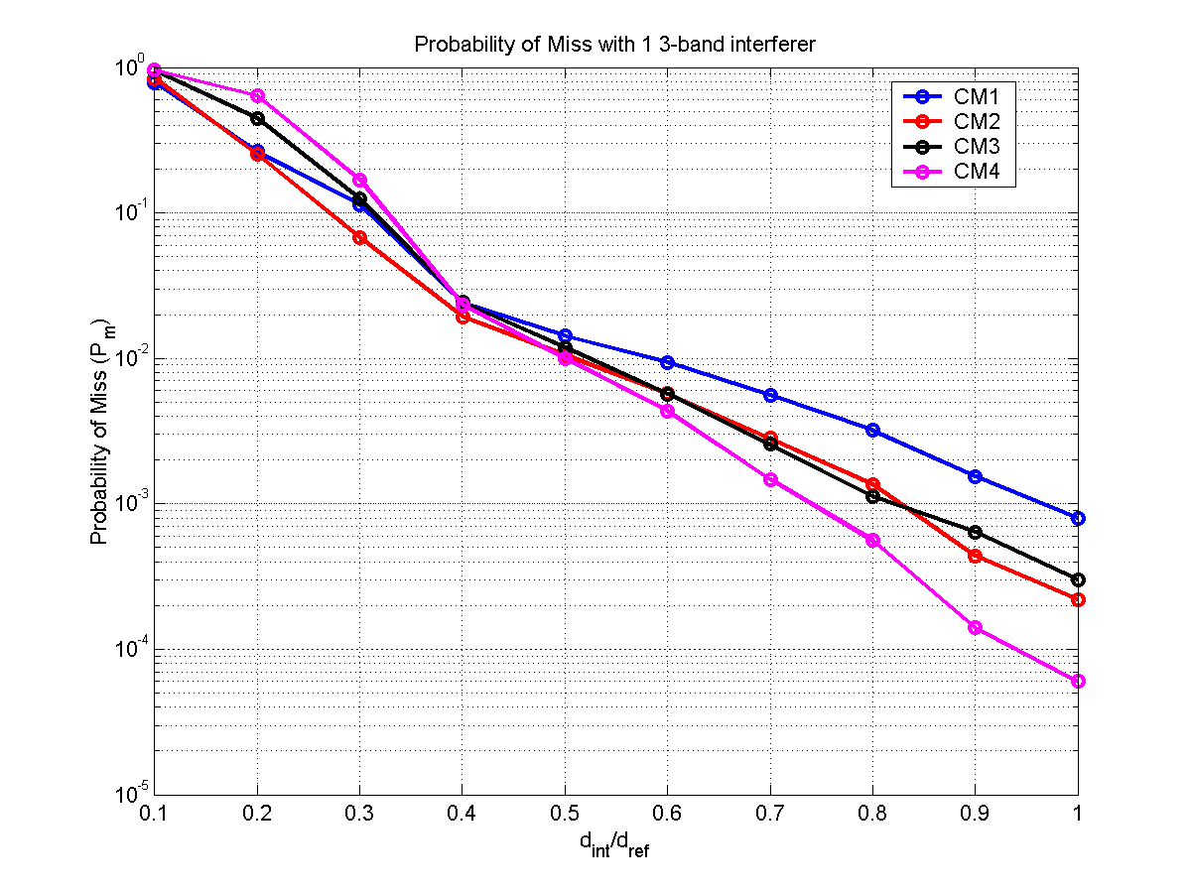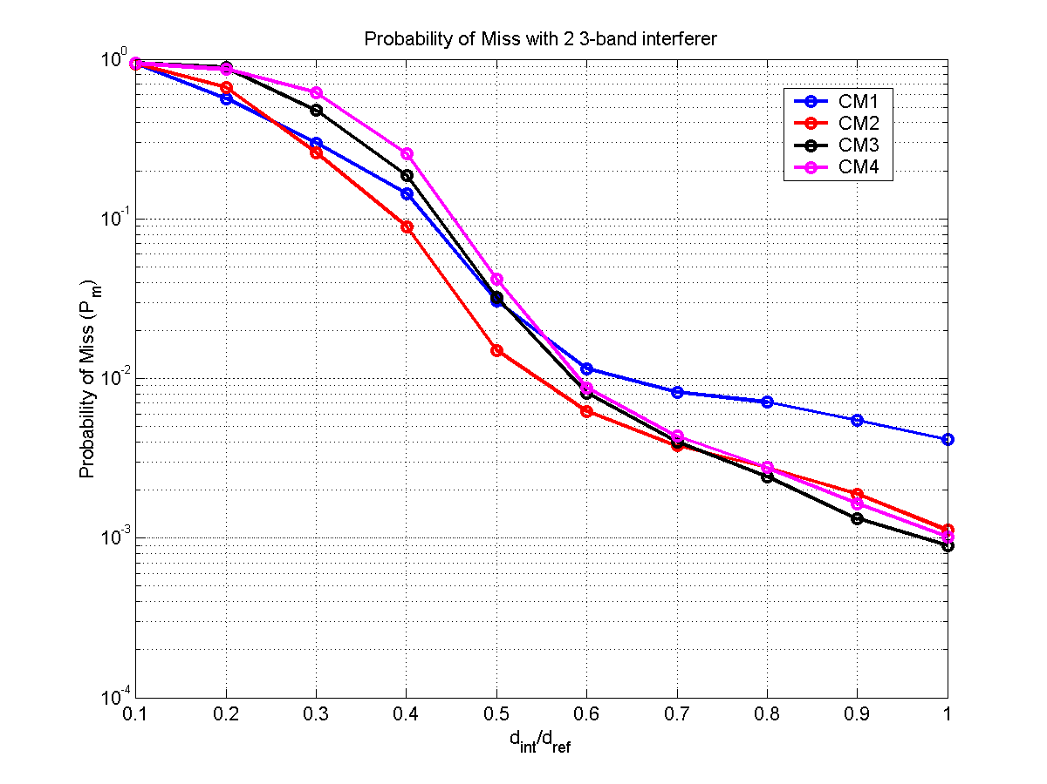

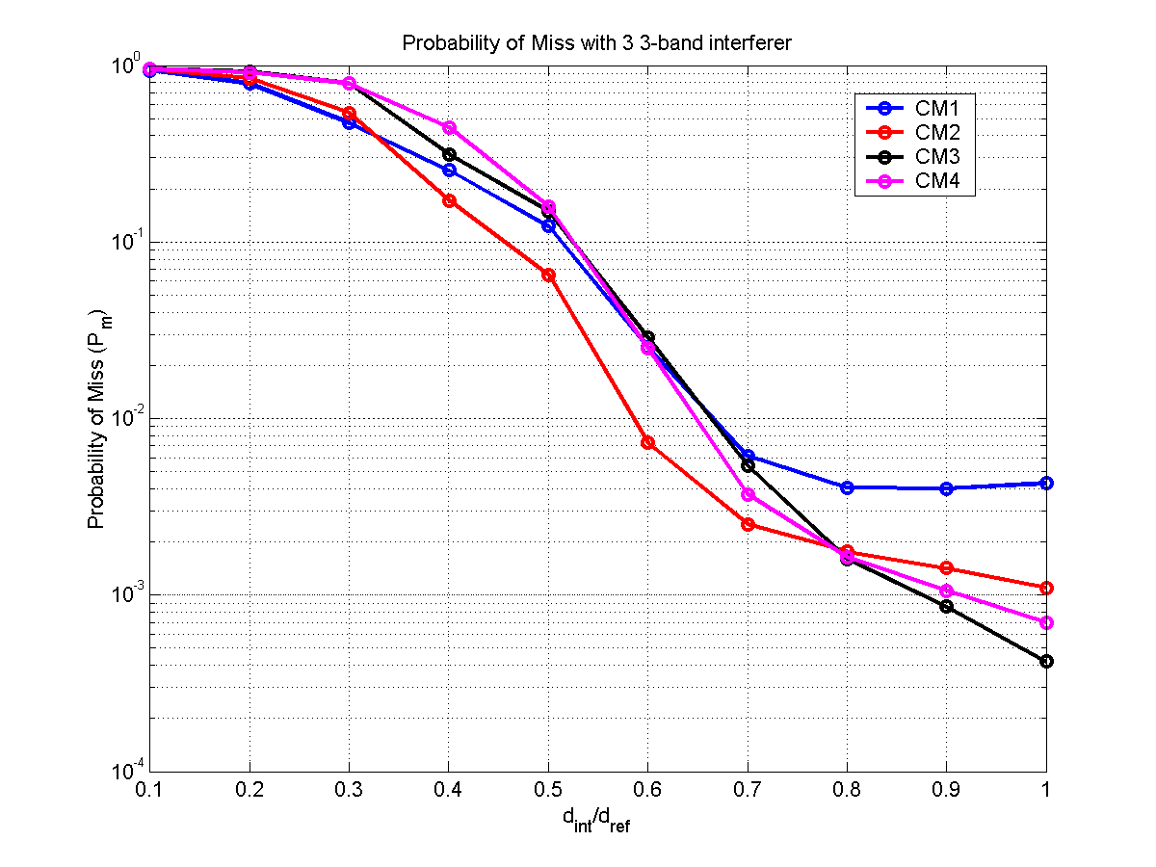

Figure 19 – Probability of miss detection versus separation distance and varying number of Mode 1 interferers.

These figures show that the packet can be acquired at a separation distance of less than 0.4 without significant impact on the packet error rate.

Signal acquisition

The standard PLCP preamble is designed specifically to be robust in low signal-to-noise environments. In fact, the standard PLCP preamble was designed to operate at 3 dB below sensitivity for an information data rate of 55 Mb/s. Table 28 provides the false alarm and miss detect probabilities for an information data rate of 110 and 200 Mb/s. These probabilities are specified for a single piconet and various channel conditions (AWGN, CM1 through CM4). These results were averaged over 50,000 realizations (500 noise realizations for each of the 100 channel realizations) for a given multi-path channel environment. These results include an offset of ±20 ppm at both the transmitter and receiver clock synthesizer. In addition, a 4-bit ADC was implemented at the receiver.

Table 28 – False detect and miss detect probabilities for a single piconet
Channel Environment | P_{m} at 110 Mb/s | P_{m} at 200 Mb/s | P_{f} | Acquistion Time
AWGN | < 2 × 10⁻⁵ | < 2 × 10⁻⁵ | 6.2 × 10⁻⁴ | < 4.69 μs
CM1 | < 2 × 10⁻⁵ | < 2 × 10⁻⁵ | 6.2 × 10⁻⁴ | < 4.69 μs
CM2 | < 2 × 10⁻⁵ | < 2 × 10⁻⁵ | 6.2 × 10⁻⁴ | < 4.69 μs
CM3 | < 2 × 10⁻⁵ | < 2 × 10⁻⁵ | 6.2 × 10⁻⁴ | < 4.69 μs
CM4 | < 2 × 10⁻⁵ | < 2 × 10⁻⁵ | 6.2 × 10⁻⁴ | < 4.69 μs

The probability of miss detection as a function of distance is plotted in Figure 20. This figure shows that the proposed preamble is robust in all multi-path channel environments, even for large distances. Again, these results were averaged over 50,000 realizations (500 noise realizations for each of the 100 channel realizations) for a given multi-path channel environment.

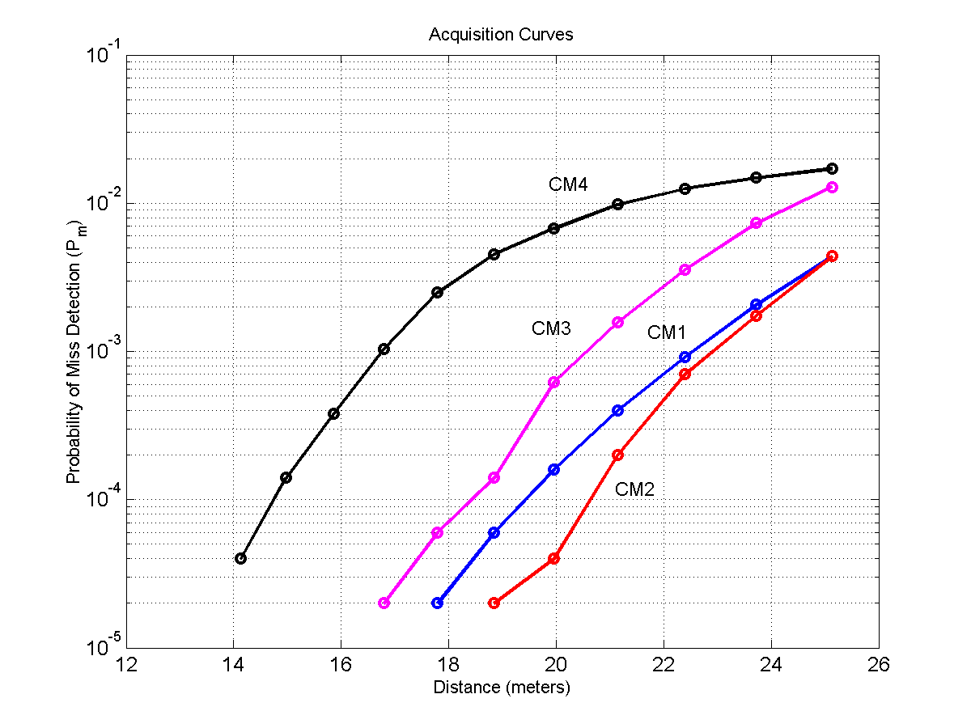
Figure 20 – Probability of miss detection as a function of distance

A timeline showing the overall acquisition process of the standard PLCP preamble is shown in Figure 21. The first 6.5625 μs are used for packet detection and acquisition, coarse frequency estimation, coarse symbol timing estimation, and AGC settling. The next 0.9375 μs are used for synchronization within the preamble, i.e., to determine the location within the preamble, and to indicate the start of the channel estimation sequence. The final 1.875 μs are used for channel estimation, fine frequency estimation, and fine symbol timing estimation.

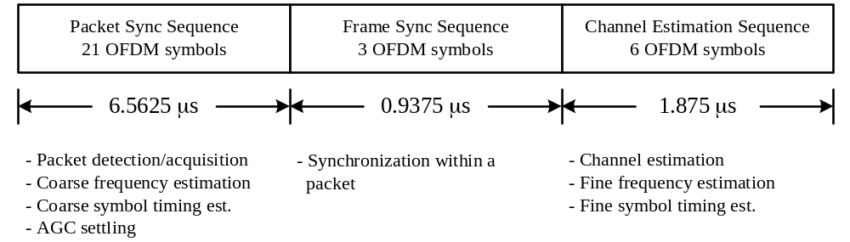

Figure 21 – Timeline for acquisition of the standard PLCP preamble

System

The performance of the Multi-band OFDM system was evaluated in AWGN and multi-path channel environments specified by the 802.15.3a channel modeling sub-committee report. A path loss decay exponent of 2 was assumed for all the four channel environments and the “new” channel realizations from each of the environments have been used for these simulations. All simulations were performed with at least 500 packets with a payload of 1K bytes each. The performance simulations incorporate losses due to front-end filtering, clipping at the DAC, ADC degradation (4-bits for 110/200 Mbps and 5-bits for 480 Mbps), multi-path, shadowing, packet acquisition, channel estimation, clock frequency mismatch (± 20 ppm at the TX and RX), carrier offset recovery, carrier tracking, etc. The PER performance for Mode 1 DEVs in an AWGN channel is shown in Figure 22 as a function of distance and the information data rate.

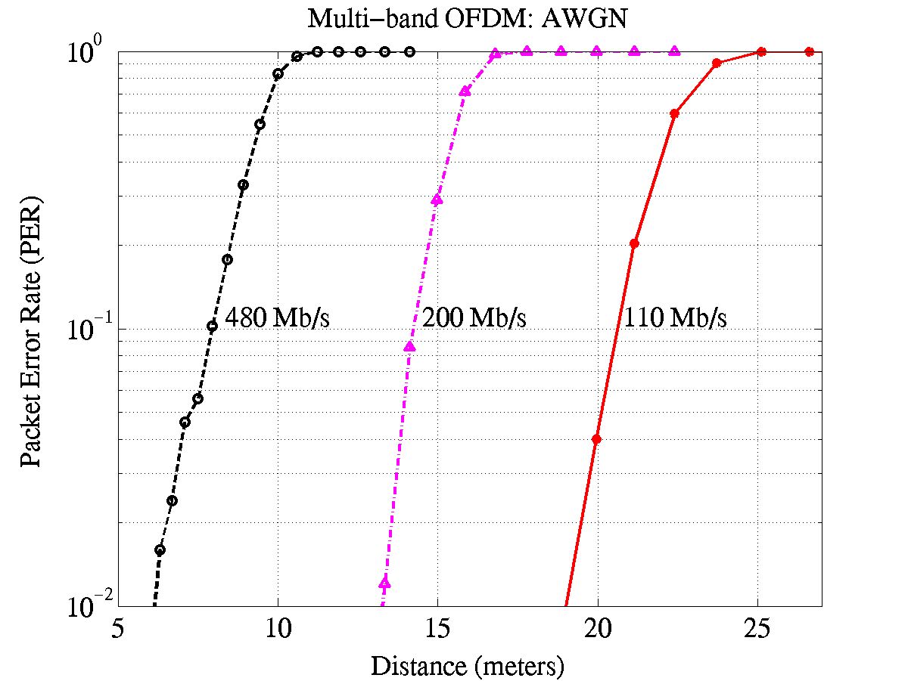
Figure 22 – PER for a Mode 1 DEV as a function of distance and information data rate in an AWGN environment.

The PER performance for the 90th %ile channel realization is illustrated in Figure 23, Figure 24, Figure 25, and Figure 26 as a function of distance for the four channel environments CM1-CM4, respectively. These plots correspond to the performance of the 90th best channel realization, i.e., the worst 10% channels were discarded. This implies that the performance of the Multi-band OFDM system is better than what is illustrated in these plots for at least 90% of the channel realizations from each channel environment.

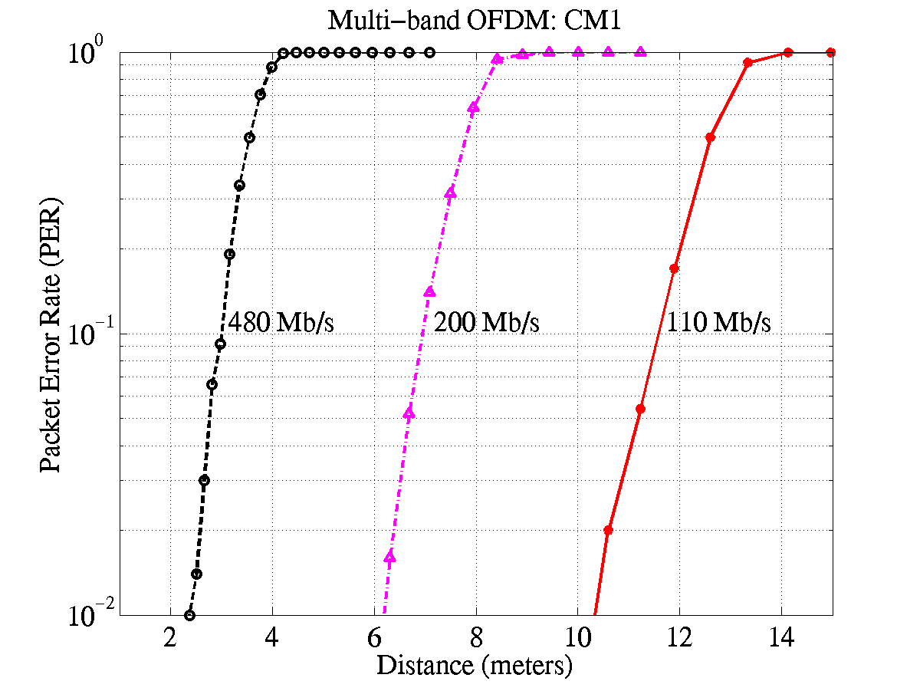
Figure 23 – PER for Mode 1 DEVs as a function of distance and information data rate in a CM1 channel environment for the 90th %ile channel realization.

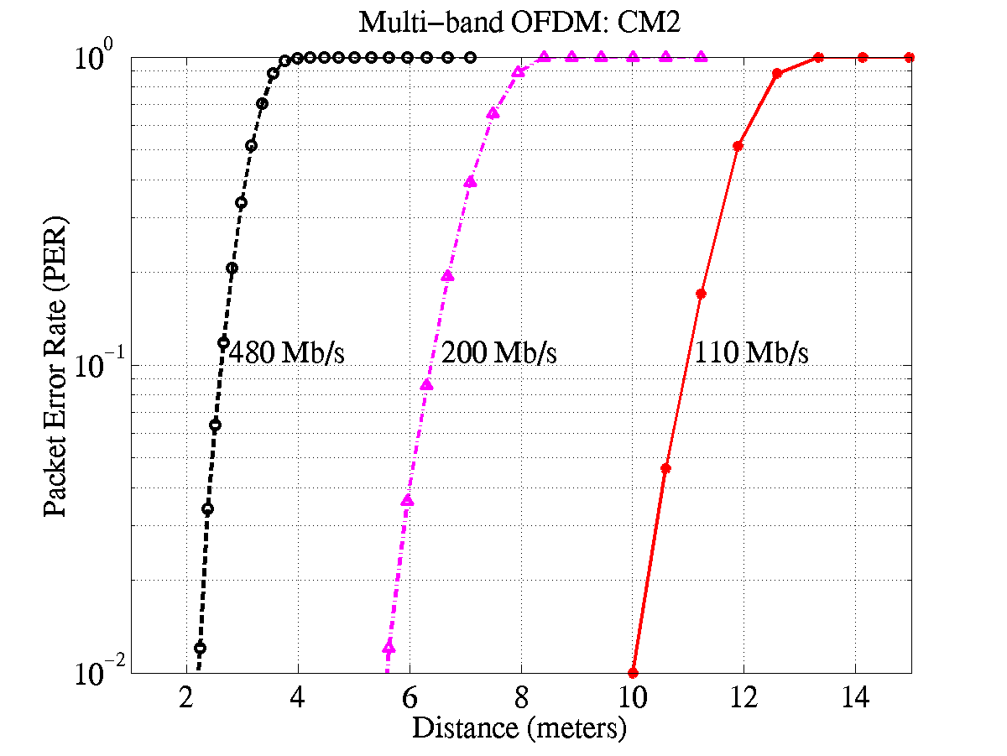
Figure 24 – PER for Mode 1 DEVs as a function of distance and information data rate in a CM2 channel environment for the 90th %ile channel realization.

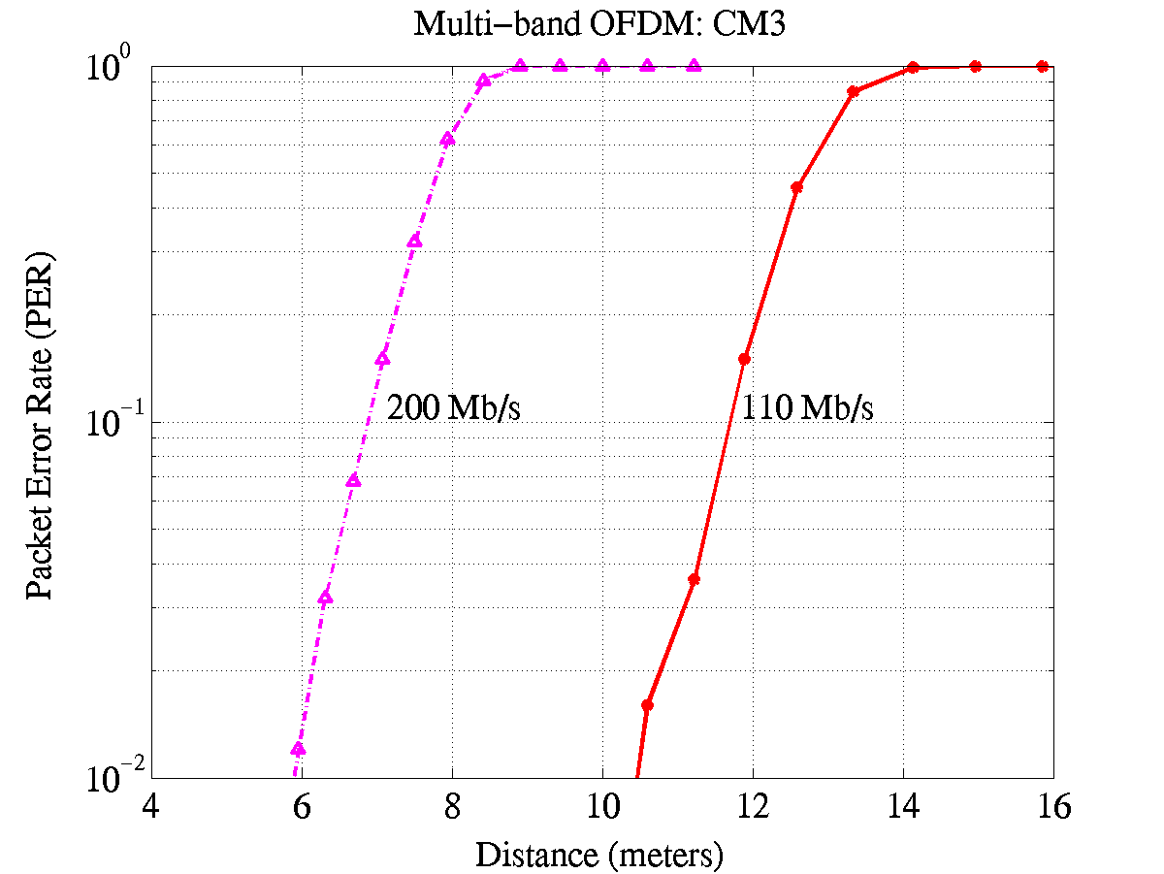
Figure 25 – PER for Mode 1 DEVs as a function of distance and information data rate in a CM3 channel environment for the 90th %ile channel realization.

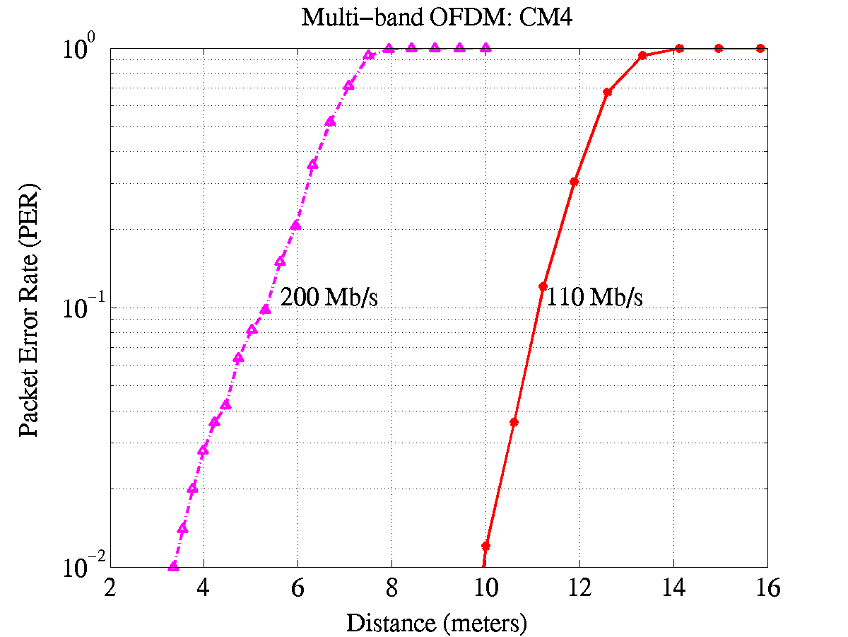
Figure 26 – PER for Mode 1 Devs as a function of distance and information data rate in a CM4 channel environment for the 90th %ile channel realization.

The range at which the Multi-band OFDM system, operating in Mode 1, can achieve a PER of 8% with a link success probability of 90% is listed in Table 29 for AWGN and the multi-path channel environments. As the link success probability is dominated by shadowing and not by signal acquisition (see Table 28), the link success probability in AWGN channel environment, for the distance values listed in Table 29, is close to 100%. In AWGN and all multi-path environments, the Multi-band OFDM system easily satisfies the data rate versus range requirement of 110 Mbps at 10 m and 200 Mbps at 4 m. Furthermore, the Multi-band OFDM system can support data rates of 110 Mbps, 200 Mbps and 480 Mbps at a distance of 10.9-11.6 m, 5-6.9 m and 2.6-2.9 m, respectively, in various multi-path channel environments for a link success probability of 90%.

Table 29 – Range to achieve a PER of 8% with a 90% link success probability for Mode 1 devices
Rate | AWGN | CM1 | CM2 | CM3 | CM4
110 Mb/s | 20.5 m | 11.4 m | 10.7 m | 11.5 m | 10.9 m
200 Mb/s | 14.1 m | 6.9 m | 6.3 m | 6.8 m | 4.7 m
480 Mb/s | 7.8 m | 2.9 m | 2.6 m | N/A | N/A

Table 30 enumerates the distance at which the mean PER of the 90 best channel realizations is equal to 8%. These values are tabulated for Mode 1 DEVs operating at different data rates and channel environments and are computed by averaging the PER of the 90 best channel realizations for each channel environment.
Table 30 – Range at which the mean PER for the best 90% channels is 8% for Mode 1 devices
Rate | AWGN | CM1 | CM2 | CM3 | CM4
110 Mb/s | 20.5 m | 14 m | 13.2 m | 13.8 m | 13.8 m
200 Mb/s | 14.1 m | 8.9 m | 8.3 m | 8.5 m | 7.3 m
480 Mb/s | 7.8 m | 3.8 m | 3.6 m | N/A | N/A

The probability of link success for the four multi-path channel environments is illustrated in Figure 27 for Mode 1 DEVs as a function of distance for an information data rate of 110 Mbps. As the Multi-band OFDM system has been designed to be robust to multi-path and with a sufficiently long cyclic prefix, the performance is similar in the four channel environments. The small variations in performance are primarily due to the effect of shadowing that has been incorporated in the 100 channel realizations corresponding to each of the four channel environments. From Figure 27 we see that the Multi-band OFDM system can support a data rate of 110 Mbps at a distance of about 10.7-11.5 m with a link success probability of 90% and a distance of 13.8-14.7 m for a link success probability of 75 %.

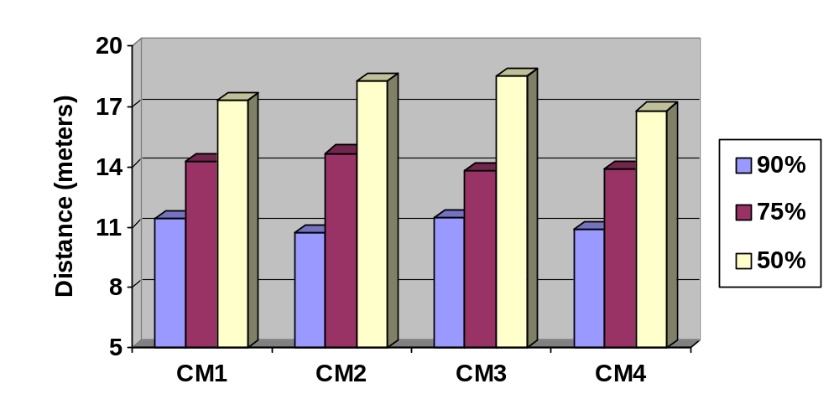
Figure 27 – Range as a function of link success probability and channel environment for an information data rate of 110 Mbps for Mode 1 devices.

Link budget

Parameter: Mode 1 DEV | Value | Value | Value
Information data rate (R_{b}) | 110 Mb/s | 200 Mb/s | 480 Mb/s
Average Tx power (P_{T}) | −10.3 dBm | −10.3 dBm | −10.3dBm
Tx antenna gain (G_{T}) | 0 dBi | 0 dBi | 0 dBi
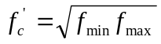: geometric center frequency of waveform (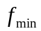 and 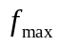 are the -10 dB edges of the waveform spectrum) | 3882 MHz | 3882 MHz | 3882 MHz
Path loss at 1 meter (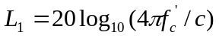)  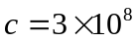 m/s | 44.2 dB | 44.2 dB | 44.2 dB
Path loss at d m (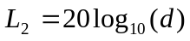) | 20 dB  (d = 10 meters) | 12 dB  (d = 4 meters) | 6 dB  (d = 2 meters)
Rx antenna gain (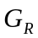) | 0 dBi | 0 dBi | 0 dBi
Rx power (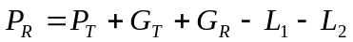 (dB)) | −74.5 dBm | −66.5 dBm | −60.5 dBm
Average noise power per bit (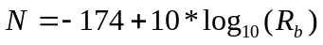) | −93.6 dBm | −91.0 dBm | −87.2 dBm
Rx Noise Figure Referred to the Antenna Terminal (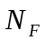)¹ | 6.6 dB | 6.6 dB | 6.6 dB
Average noise power per bit (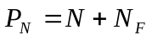) | −87.0 dBm | −84.4 dBm | −80.6 dBm
Required E_{b}/N₀ (S) | 4.0 dB | 4.7 dB | 4.9 dB
Implementation Loss² (I) | 2.5 dB | 2.5 dB | 3.0 dB
Link Margin (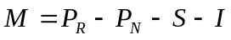) | 6.0 dB | 10.7 dB | 12.2 dB
Proposed Min. Rx Sensitivity Level³ | −80.5 dBm | −77.2 dBm | −72.7 dBm

¹ The primary sources for the noise figure are the LNA and mixer. The voltage gain of the LNA is approximately 15 dB, while the voltage conversion gain of the mixer is approximately 10 dB. The total noise at the output of the LNA is 0.722 × 10^{–16} V²/Hz. This value includes the noise of the LNA and the input of resistor. The total noise at the output of the mixer is 0.722 × 10^{–16} V²/Hz + 0.1*(8 × 10^{–9})² V²/Hz = 0.786 × 10^{–16} V²/Hz, where the second term in the addition is generated by the noise sources within the mixer. Thus, the overall noise figure for the analog front-end is 10log₁₀(7.86/2.56) = 4.9 dB. Including the losses associated with the pre-select filter (1.1 dB) and the transmit/receive switch (0.6 dB), the overall noise figure is 6.6 dB.
² Includes losses due to cyclic prefix overhead, front-end filtering, clipping at the DAC, ADC degradation, channel estimation, clock frequency mismatch, carrier offset recovery, carrier tracking, etc.

Sensitivity

For a packet error rate (PER) of less than 8% with a PSDU of 1024 bytes, the minimum receiver sensitivity numbers for the various rates and mode of operation are listed in Table 18.

Table 31 – Receiver performance requirements
Data rate (Mb/s) | Minimum sensitivity for Mode 1 DEV (dBm)
55 | −83.5
80 | −81.7
110 | −80.5
160 | −78.7
200 | −77.2
320 | −75.1
480 | −72.7

Power management modes

The proposed PHY system shall support all of the power managements modes (ACTIVE, PSPS, SPS, and HIBERNATE) defined the IEEE 802.15.3 draft standard.

Power consumption

The power consumption calculations are provided for both a 90 nm CMOS technology node that will be available in early 2004 and a 130 nm CMOS technology node that is currently available. In addition, for the 90/130 nm process node a supply voltage of 1.5/1.8 V was assumed for the analog section of the PHY, except for the LNA where a 2 V supply was assumed. The digital section of the PHY requires a supply voltage of 1.2/1.3 V (for the 90/130 nm process node) and a clock of 132 MHz. Using these assumptions, the power for transmit, receive, clear channel assessment, and power save were calculated. The resulting power consumption values are listed in Table 32.

Table 32 – Power consumption for Mode 1 DEV
Process Node | Rate (Mb/s) | Transmit | Receive | CCA | Power Save (Deep Sleep Mode)
90 nm | 110 | 93 mW | 155 mW | 94 mW | 15 μW
90 nm | 200 | 93 mW | 169 mW | 94 mW | 15 μW
90 nm | 480 | 145 mW | 236 mW | 94 mW | 15 μW
130 nm | 110 | 117 mW | 205 mW | 117 mW | 18 μW
130 nm | 200 | 117 mW | 227 mW | 117 mW | 18 μW
130 nm | 480 | 180 mW | 323 mW | 117 mW | 18 μW

Antenna practicality

The antenna is assumed to have the following characteristics across the bandwidth of interest: frequency-independent gain and omni-directional patterns. The remaining requirements for the antenna can be relaxed because OFDM has an inherent robustness against gain, phase, and group delay variation that may be introduced by the antenna. A 16 mm × 13.6 mm x 3 mm antenna with similar characteristics is already commercially available at a low cost and can meet many of the form factors specified in the selection criteria document.

Component area.
This is a pessimistic analysis performed for the sub-band closest to the interferer and does not include the processing gain of 10log₁₀(3) dB that arises from the use of Time-Frequency Codes across the 3 bands.

